Sexual Assault Victims in Honolulu: A 2001 – 2010 Statistical Profile

Dawna Nelson, MSW
Evelyn Yanagida, Ph.D.
Carol Plummer, Ph.D.
Copyright 2012 by the Sex Abuse Treatment Center, Kapi‘olani Medical Center for Women and Children, an affiliate of Hawai‘i Pacific Health. All rights reserved. No portion of this report may be reproduced, in whole or in part, in any form or by any means, electronic or mechanical, including photocopying, recording or by any information storage and retrieval system now known or hereafter invented, without prior written permission from the Sex Abuse Treatment Center.

Funds for this report were provided by the Hawai‘i State Department of the Attorney General, Crime Prevention and Justice Assistance Division.
ACKNOWLEDGMENTS

We acknowledge and thank Annie Hollis, B.A., MSW candidate (2013) for help with editing/formatting. We would also like to thank the staff of the Sex Abuse Treatment Center for their support and donation of time, assistance, and valuable input towards completing this report. This material was approved by the Institutional Review Boards of the Kapi‘olani Medical Center for Women and Children and the University of Hawai‘i at Manoa. The opinions, findings and conclusions expressed in this publication are those of the authors and do not necessarily reflect the views of Kapi‘olani Medical Center for Women and Children or the University of Hawai‘i. The authors have no conflicts of interest relevant to this study.
TABLE OF CONTENTS
LIST OF FIGURES ii
LIST OF TABLES ii
EXECUTIVE SUMMARY 1
SECTION 1: BACKGROUND 6
Current Study 6
The Sex Abuse Treatment Center 7
Victim Characteristics 10
Assault Characteristics 14
Prevalence of Sexual Assault Nationally and in Hawai‘i 16
SECTION 2: DEMOGRAPHIC PROFILE 19
Victim Profile – Hawai‘i 19
Assault Characteristics –Hawai‘i 22
SECTION 3: TRENDS 32
Introduction 32
SECTION 4: VICTIM POLICE REPORTING 38
Background 38
Predictors for Reporting to Police: Adults 41
Predictors for Reporting to Police-Juveniles 43
Predictors for Reporting-Males 45
Predictors of Reporting to Police- Females 47
SECTION 5: ALCOHOL AND LEVEL OF ASSAULT RISK 50
SECTION 6: DISCUSSION AND IMPLICATIONS 58
REFERENCES 66
APPENDIX A: SEX ABUSE TREATMENT CENTER ACTIVITIES 71
APPENDIX B: FREQUENCY OF VARIABLES USED IN REPORT 73
APPENDIX C: COLLAPSING OF VARIABLES 75
Definitions of variable code/categories 75

LIST OF FIGURES

Figure 1: Flowchart of Common SATC Access Points 9
Figure 2: Comparison of Hawai‘i’s Forcible Rape Rate with the National Forcible Rape Rate 17
Figure 3: Age Distribution of Female and Male Sexual Assault Victims 19
Figure 4: Sex of Victim by Intake Year 21
Figure 5: Time of Assault by Gender 25
Figure 6: Time of Assault by Offender-Victim Relationship 26
Figure 7: Percent of Victims Exposed to Assailant Strategies by Gender 29
Figure 8: Percent of Victims by Gender 32
Figure 9: Victim Age at Assault by Gender 2001-2010 33
Figure 10: Ethnicity of Victims 2001-2010 34
Figure 11: Female Victim-Assailant Relationship 2001-2010 (n=4226) 34
Figure 12: Male Victim-Assailant Relationship 2001-2010 (n=353) 35
Figure 13: Time of Assault for Adult Victims 2001-2010 36
Figure 14: Time of Assault for Minor Victims 2001-2010 36
Figure 15: Reports to Police by Gender 2001-2010 37
Figure 16: Percent of Victims Reporting to the Police by Age Status, 2001-2010 37
Figure 17: Number of Victims Served by Gender 1990-2010 59
Figure 18: Percentage of Victims Served by Age Group 59

LIST OF TABLES
Table 1: Demographic Characteristics of Sexual Assault Victims Seeking Treatment at SATC, 2001-2010 (Percentages) 20
Table 2: Relationship of Offender to Victim by Age and Gender 23
Table 3: Relationship of Assailant to Victim by Age Categories (Percentages) 24
Table 4: Location of Assault, by Age and Gender (Percentages) 27
Table 5: Assailant Assault Strategies by Age at Assault (Percentages) 30
Table 6: Referral to SATC by Age and Gender (Percentages) 31
Table 7: Location of Assault by Gender and Age 36
Table 8: Percentage of Victims Reporting to the Police by Age and Gender 40
Table 9: Police Reporting by Age and Case Type 40
Table 10: Adult Victim Reporting Behavior (Percentages) n=1724 42
Table 11: Juvenile Victim Reporting Behavior (Percentages) N=2493 44
Table 12: Male Victim Reporting Behavior (Percentages) N=533 46
Table 13: Female Victim Reporting Behavior (Percentages) n=3696 48
Table 14: Use of Alcohol and Drug Use Prior to Assault (Percentages) 53
Table 15: Characteristics of Adult Sexual Assault Victims and Assailant Use of Alcohol (Percentages) 55
Table 16: Characteristics of Juvenile Sexual Assault Victims and Assailant Use of Alcohol (Percentages) 56
Table 17: Percentages of Clients by Ethnicity, 1990-2001 compared to 2001-2010 60

EXECUTIVE SUMMARY

This report provides a descriptive analysis of 4,834 sexual assault victims who received services through the Sex Abuse Treatment Center (SATC) in Honolulu, Hawai‘i from mid-2001 through 2010. It also examines trends over the past twenty years across 9,929 victims, comparing these findings with those from the prior decade. Survivors of recent assaults as well as adults who were sexually assaulted as children were represented in this study. Furthermore, the type of assaults spanned the entire spectrum of sexual violence (i.e., fondling, penetration, harassment, etc.). These data represent a limited sample of sexual assault survivors in Hawai‘i as many victims do not disclose or report their assault, do not seek treatment at SATC or may receive treatment elsewhere (see Figure 1). Additionally, the findings and conclusions of this study do not necessarily represent the views of Kapi‘olani Medical Center for Women and Children. Nonetheless, this report provides useful information on a sample of sexual assault victims in Honolulu over a twenty year span, and one which can be compared against national trends.
Key Findings
- Honolulu data on sexual assault has been remarkably consistent over time and closely aligns with national statistics. It is alarming to realize that children and youth compromised a significant majority of sexual assault victims that were seen through SATC. In the first ten years examined, 56% of victims were under age 18 and in the second decade, 57% were minors. In fact, a 34% increase in 12-15 year old victims was seen over this 20 year time frame. Victims in Honolulu were most often females (88% across the current 10 year period) and offenders most often males (97.4%). Weapons were used in less than 10% of the cases, although injuries were evident about 25% of the time. The average victim during this reporting period was 18 years old when assaulted. However, males were an average of 13 years old. Over the past ten years, victims 11 years and younger were most likely to be assaulted by family members. Eighty-three percent of victims knew their assailant with 13.3% of the victims reporting they were assaulted by a stranger. In 2001-2010, about 16% of victims were assaulted by strangers. Twenty percent of adult assaults were perpetrated by strangers while only 7.5% of assaults of minors were committed by strangers. For both sexes during the past ten years, assaults were most likely to occur in the victim’s (44.7%) or assailant’s (31.6%) home, hotel, or workplace. The levels of sexual assault and abuse in Honolulu neither increased nor decreased significantly over the twenty year period and were consistent with national trends.
- People of Hawaiian ancestry continue to be the largest group of survivors seeking services at SATC. The largest ethnic categories of victims served were: Hawaiian/part-Hawaiian (28.2%), Caucasian (22.7%), and mixed ethnic heritage, not including Hawaiian (22.4%). Over the entire 20 years surveyed, this trend was consistent. It is unclear from the data if this indicates higher rates of sexual violence for Hawaiians or a greater willingness to utilize SATC services due to proximity, convenience, experience or other factors.
- Referrals to SATC have changed significantly over time with more referrals now coming from schools, workplaces, and agencies other than the police. While positive relationships continue between law enforcement and SATC, awareness of SATC services by these other referral sources is very beneficial for connecting victims with assistance.
- There have been some changes regarding reporting sexual assault cases to the police. SATC rates of victims reporting their assault to the police (71.1%) is higher than national numbers (16-20%), primarily because a large number of referrals to SATC initially come from the police, where victims first sought assistance or had the opportunity or knowledge to file a police report. This reporting rate is essentially the same relative to the previous 10 year period in which 68% of victims reported the assault to the police. As a whole, adult victims were more likely to report their assault if the assailant was a stranger, if there was only one perpetrator (as opposed to multiple perpetrators), if threats were involved and if the assault occurred within the past 72 hours. A further breakdown shows increased reporting of cases of juvenile victims regardless if the case was a recent or past assault. This change may indicate that professionals are aware of and complying with mandatory reporting laws with greater frequency.
- Alcohol use plays a significant role in sexual assaults of both children and adults. In this study, on average, over half of all offenders had been or were using alcohol at the time of the assault, according to the victims. In particular, assailants were significantly more likely to have used alcohol if there were multiple offenders (66% in cases of one offender versus 84%) and if the victim was female (69% versus 51% with male victims). If the offender was a stranger or acquaintance, he was more likely to be using alcohol than if the assailant was an intimate partner or related to the victim. Caucasian victims were significantly more likely to be assaulted by an offender under the influence (81% versus 58% for Hawaiian or part-Hawaiian victims). Offenders’ use of alcohol also appeared to increase the level of violence against the victim. In addition, female victims were more likely to have consumed alcohol prior to the assault than males (28% versus 8%), although this difference is partially related to the older average age of females (19 years) versus males (13 years). The use of alcohol by assailants has remained relatively stable over the past 20 years while victim use of alcohol increased in this reporting period for both genders. Assailant drug use, while possibly harder to detect, was reported by victims in 10% of male assaults and 22% of female assaults over the past ten years. While this figure was relatively stable for females across 20 years, assailant drug use with male victims doubled in the last 10 years.

It is discouraging to see higher rates of Hawaiian/part Hawaiian victims, although the meaning of this increase is unclear. It may be that cultural trauma and its concomitant consequences have contributed to higher rates of sexual assault in this population. It may also mean that SATC efforts to develop culturally specific educational and outreach materials for the local population have worked to attract more Hawaiian/part Hawaiian victims to the Center. Given lower rates of service use by other racial and ethnic groups, adapting prevention approaches and materials may result in an increase in service use by more diverse populations.

We believe that the trend of significantly more referrals coming from sources other than the police is a good one. While the relationship between police and SATC is very strong, the movement towards more referrals from schools, colleges and workplaces suggest more awareness of SATC as a resource in the broader community. This increased support provides multiple pathways for victims to access information and services.

Reporting cases to law enforcement also showed some interesting trends. The clearest trend shows that official police reports are increasing in cases of sexual assault of children and youth. This may be partly due to mandatory reporting laws encouraging reports, but also due to adult concern and compliance with reporting mandates. Fewer adult reports emerged for victims who were assaulted in the past. Although adult reports for recent assaults were roughly at the same levels as previous findings, this still leaves a sizable percentage of victims who do not report. Nonetheless, recent trends suggest that victim referrals are coming from a wider range of agencies or individuals than the police. Additionally, there may be increased public awareness that police reports are optional and one can seek confidential services at SATC for symptoms post-assault without involving law enforcement. Thus, more victims may be accessing treatment services even if they do not wish to pursue criminal remedies.

This report also underlines the importance of alcohol as a factor in sexual assaults in Honolulu. While victim use of alcohol does not cause sexual assault, education on risk management, especially among young adult women where alcohol use peaks, may help to augment behaviors that promote safety. Additionally, joint efforts between community groups could begin to address the dangers posed by alcohol use by offenders and strategies for reducing these risks can be explored. For example, involvement of owners of bars, increased awareness that impaired judgment is not an excuse for rape, and increased bystander involvement with potential offenders could lead to innovative ways to address this concern.

This report revealed both similarities and differences in victim trends compared to the prior 10 year period. Despite prevention efforts, sex assault continues to be a safety concern in our community and resources need to be committed to assure that victims receive the services they deserve.

Disclaimer: The majority of victims of sexual violence are female and most sex offenders are male. While we strive to be gender neutral, in this report we often refer to a victim as she/her and an offender as he/him. This does not mean that a man or boy cannot be a victim of sexual assault or that a woman cannot be an offender.

The terms ‘victim’ and ‘survivor’ are used in this handbook. We are aware that some may take issue with the term ‘victim’ but we use it to highlight the fact that you are forced to be a victim, but can choose to be a survivor.

Thank you for understanding these editorial decisions.

SECTION 1: BACKGROUND

Current Study
The purpose of this report is to provide updated information on victims receiving services from the Sex Abuse Treatment Center (SATC) and to compare and contrast this information to victims seen in the previous 10 years . This report presents descriptions and analyses from the time period between 2001 and 2010 as well as compares and contrasts trends from the previous ten year period between 1990 and 2001. The previous report analyzed data from the first six months of 2001, while this report includes the remainder of the year. Thus, this report actually reflects a 9.5 year time frame. All descriptive data and analyses were generated from a data set created from demographics and service profiles of sexual assault survivors presenting for services on the island of Oahu at the SATC. The dataset includes all sexual assault victims, regardless of whether they reported to the police and is inclusive of all assault types. Therefore the report captures additional victims that may not be included in law enforcement data. However, SATC does not service every case that is reported to the police and some survivors may seek private or informal resources. Additionally, the data presented represents only those who sought services on the island of Oahu.
SATC is not a research facility and its primary mission is to provide direct services to victims of sexual assault. Therefore, there were several limitations to the data. First, missing information in some data fields limited the generalizability of the findings (see Appendix B). Clients who were classified as Domestic Violence referrals were more likely to be missing demographic information and may have artificially inflated estimates of sexual violence as some were not victims of sexual assault. Thus, clients residing in domestic violence shelters were excluded from the analysis. Among the remaining clients, information was most likely to be missing on assault characteristics rather than victim demographics or assault type. Second, much of the available information was provided by victim self-report. Information regarding assault and assailant characteristics may therefore be speculative due to the victim not knowing or being unable to recall details. This was especially true in cases of stranger assault. For this reason, we have excluded variables relating to the assailant demographics. Finally, data on assault characteristics was limited to assault type and excluded information on victim response (i.e., resistance). Empirical research commonly uses victim response as an independent variable to predict long term impacts of sexual assault on individual functioning. Though victim information should not be used to represent the impact of sexual assault, it is important to understand the profile of victims seeking services as it informs both intervention and prevention efforts at the SATC.

The sample was obtained by importing variables relating to assault, victim and assailant characteristics into a database for each year between the periods of 2001-2010. Some variables were collapsed to make usable information (e.g., assault locations were collapsed from specific locations to five broad categories). Classification of categories was based on the previous decennial report as well as the current authors identifying how the information could be most interpretable and useful (see Appendix C). Descriptive analyses were conducted for the entire sample. Bivariate and multivariate analyses were conducted to evaluate within and between group variance on sexual assault characteristics. Chi-square tests were conducted to identify statistically significant relationships. Relationships between variables were considered significant if they had a p-value of .05 or less.

The Sex Abuse Treatment Center
The Sex Abuse Treatment Center is a community-based treatment and prevention program of the Kapi‘olani Medical Center for Women and Children, an affiliate of Hawai‘i Pacific Health. The SATC’s mission is to support the emotional healing process for all children and adults sexually assaulted on the island of Oahu in Hawai‘i, to increase community awareness about the needs and concerns of sexual assault victims and, ultimately, to eliminate sexual violence. Created in 1976 due to community concern about the lack of adequate and appropriate care for victims of sexual violence, the SATC has provided a comprehensive array of crisis intervention, treatment, and prevention education services for sexual assault survivors, their families, and the general public for over 35 years.
SATC provides the full array of crisis intervention services including: a 24-hour hotline, a forensic examination to provide the victim the necessary medical assessment and treatment, the collection and preservation of forensic evidence should the victim decide to take criminal action, and in-person crisis counseling and follow-up. Short and long term therapy is also available to assist victims in their recovery from the assault. Finally, SATC provides community outreach and education activities to increase public awareness about sexual assault.
The SATC assists victims of recent and past assaults, women as well as men, and both adults and minors. Cases under the jurisdiction of Child Welfare Services (CWS) are not typically referred to SATC unless there are no plans for reunification with the offender (usually a family member). Thus, intra-familial abuse of minor children was under-represented in this sample of sexual assault victims. The SATC does not work with offenders, so CWS refers cases to SATC where the offending parent or adult figure has been removed from the home and there is no goal for reunification. SATC sees child cases in which the offender is outside of the family system (e.g., teacher, coach) or adult cases where typically the assailant is an acquaintance, friend or intimate partner.
Sexual violence covers a range of unwanted behaviors involving both contact and non-contact activities (e.g., penetration, fondling, exposure and harassment). The SATC services victims across the whole spectrum of sexual violence, delivering crisis, medical and therapy services for the island of Oahu. It is important to note that many victims do not access such services. Some victims initiate counseling services through other agencies or with various private providers in the community. Figure 1 illustrates the multiple points of entry for sexual assault victims into the various service and law enforcement sectors. There are a significant number of victims who choose not to report their assault to police or to seek services. Thus, the individuals who seek SATC services represent a unique subset of sexual assault victims and do not necessarily reflect the entire population of victims who have been sexually assaulted and reside on Oahu. Figure 1 illustrates the various places victims can exit services, either voluntarily or due to no follow-up.

Figure 1: Flowchart of Common SATC Access Points

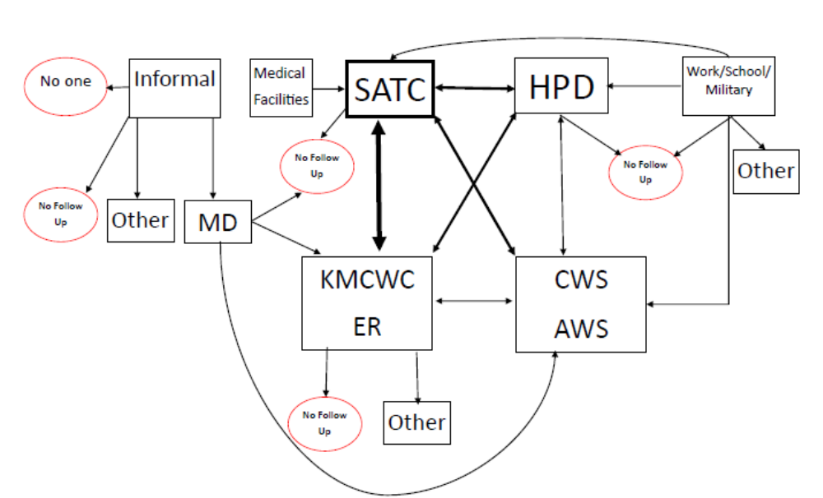
Introduction
According to the National Center for Victims of Crime (NCVC), sexual violence takes many forms (e.g., attacks such as rape or attempted rape or any unwanted sexual contact or threats) and a sexual assault “…occurs when someone touches any part of another person's body in a sexual way, even through clothes, without that person's consent” . The Centers for Disease Control (CDC) take a broader view in defining sexual violence as:
“…any sexual act that is perpetrated against someone's will. Sexual violence encompasses a range of offenses, including a completed nonconsensual sex act (i.e., rape), an attempted nonconsensual sex act, abusive sexual contact (i.e., unwanted touching), and non-contact sexual abuse .”
Additionally, digital technology has extended the spectrum of sexual violence (e.g., sexting).

The definition of sexual violence varies widely across individual state jurisdictions. The lack of consensus has often hampered efforts to examine factors related to both victims and assailants. The FBI’s Uniform Crime Reports previously defined forcible rape as “the carnal knowledge of a female, forcibly and against her will.” In 2011, the definition was revised as follows: “the penetration, no matter how slight, of the vagina or anus with any body part or object, or oral penetration by a sex organ of another person, without the consent of the victim”. This definition corrects some of the shortcomings of the previous definition in that it includes any gender of victim and perpetrator, not just women being assaulted by men. The updated definition also acknowledges that sexual assault with an object can be as traumatic as penile/vaginal rape and that victims may be unable to give consent because of mental or physical incapacity, the use of drugs or alcohol or because of age.
As a result of this more inclusive definition, it is anticipated that reported crimes of rape are likely to increase. Past studies which relied upon the FBI UCR statistics consistently showed that male on female forcible rape was one of the most underreported offenses to law enforcement. Recent information from the National Crime Victim Survey (NCVS) revealed a police reporting rate of nearly 50%, which is substantially higher than what has been reported in the past . The NCVS data included rape as well as other sexual assaults and victims of both genders. Additionally, extant research has found the incidence of sexual assault varies by both victim and assault characteristics. Therefore, findings from studies may vary depending on the source of the data (e.g., community samples, law enforcement data, etc.) and variables assessed (e.g., child sexual abuse, forcible rape, sexual assault, etc.). It should be noted that this study includes a sexual assault definition which is broader than forcible rape or definitions of some of the studies cited. Therefore, in interpreting our findings, it is important to do so cautiously, particularly in regards to comparisons with other studies which may be using different inclusion criteria.

Victim Characteristics
Age
Since the mid-1990’s the rate of violent crime including sexual assault has declined, but based on the most recent crime statistics from the U.S. Department of Justice , teens and young adults continue to be the most vulnerable. According to the 2010 Criminal Victimization Report, the annual incidence of sexual victimization per 1,000 persons aged 12 and over is: 2.7 for 12-14 age group; 1.7 for 15-17 age group; 1.1 for 18-20 age group; 1.5 for 20-24 age group and 1.3 for 25-34 age group. Thereafter the rates dropped significantly (e.g., 0.6 for 35-49 age group). This data was supported by studies finding that older children were more likely to be sexually victimized, particularly between the ages of 5 -17 years. Similarly, in a 10 year review, Putnam reported that the incidence of child sexual abuse increases with age as follows: 0-3 years old: 10% of victims; 4-7 years old: 28.4% of victims; 8-11 years old: 25% of victims and 12 and older: 35.9% of victims.
According to CDC’s 2010 National Intimate Partner and Sexual Violence Survey , nearly 80% of female victims of completed rape were first raped before the age of 25 and 42% were first raped before the age of 18 years. Additionally, nearly 28% of male victims of completed rape were first raped when they were 10 years of age or younger. These data support studies that show that older children may be at greater risk for sexual assault, although this increased risk may be due to varying reporting definitions (i.e., the age at which the child was assaulted versus the age at which the child reported the assault). Thus, the higher incidence of reporting among older children may not necessarily mean they are more vulnerable.

Gender
It is well established that females, especially among adult victims, are sexually assaulted more frequently than males. For example, Elliott and colleagues examined the prevalence of adult sexual assault in a stratified random sample of the general population. Of the 941 participants, adult sexual assault was reported by 22% of women and 3.8% of men.

Recent statistics revealed that 8% of self-reported sexual assault victims ages 12 and older were male. The discrepancy in these reported prevalence rates has to be tempered against the likelihood that socio-cultural barriers make it more difficult for males, particularly teens and adult men, to report their assaults.

While adult males are assaulted less frequently than females, the frequency of male assaults among minors is higher relative to adults. According to Putnam’s10 year review , 25% of sexual assault child victims were male. This finding was supported by a recent study which used data from the 2001-2005 National Incident Based Reporting System (NIBRS) to construct an epidemiological profile of male sexual assault . Results revealed that the incidence of sexual assault was higher among young males (less than 19 years of age) than older males with approximately 90% of all cases being reported among members of this age group. However, these higher reporting percentages may be linked to mandated reporting requirements for suspicions of child sex abuse.

Marital Status
Victims who were not married had significantly higher rates of sexual violence than victims who were married, widowed, divorced or separated . This finding is probably confounded with age. For all personal crimes, unmarried, divorced and separated victims were equally at risk. This is supported by research findings that divorced and separated men and women experienced similar overall rates of violent victimization .

Race and Ethnicity
The findings about race and ethnicity as risk factors for sexual assault victimization have historically been based on Caucasian samples. Studies that include more racially and ethnically diverse samples appear inconclusive. In some instances, apparent differences in ethnicity or culture in reporting or reactions may be more related to differences in abuse characteristics among or between groups, or to levels of acculturation than to cultural differences per se .

Rickert and associates reported higher proportions of forced sexual assault among African Americans whereas Maxwell and colleagues reported no differences. For minors, Finkelhor, Hammer & Sedlack found that black and white children experienced near-equal levels of sexual abuse while other studies have reported that both blacks and Latinos have an increased risk for sexual victimization.
More recently, Freeman and Temple found that adolescents of multi-ethnic descent (primarily African American and Hispanic) were substantially more likely to report sexual assault than their counterparts, but factors related to reporting of sexual violence may be very different from its actual prevalence. Furthermore, these findings may be confounded by other factors known to be related to increased risk of child sexual assault such as parental impairment (e.g., inadequacy, unavailability, conflict, use of substances, etc.). Race and ethnicity alone may not necessarily increase vulnerability specific to sexual assault but may influence trauma symptom expression.

In a study more relevant to Hawai‘i’s population, Crisanti and colleagues examined data on unwanted sexual experiences from the 2006-2007 Hawai‘i Behavioral Risk Factor Surveillance System (N=12,573 of an adult, community-based sample). Participants were 44% Caucasian, 41% Asian and 15% Native Hawaiian/Other Pacific Islander (NHOPI). Data revealed that NHOPIs had a higher 12 month period prevalence for unwanted sexual experiences (prevalence of 2.24 per 100) but a lower prevalence estimate for any lifetime unwanted sexual experience (prevalence 9.38 per 100). In contrast, Asian Americans had lower prevalence estimates for 12 month and lifetime period prevalence (0.78 and 3.91 per 100, respectively). The 12 month and lifetime prevalence estimates for Caucasians was 0.71 per 100 and 12.01 per 100, respectively). The authors concluded that there were ethnic and racial differences in sexual assault prevalence across these groups, with the relative risk contingent upon the time period . In order to fully interpret these findings, one also has to weigh the inter-relationship between socio-economic and ethnoracial status as factors that influence prevalence.

Assault Characteristics
Victim / Assailant Relationship
Recent information continues to support the well-established finding that the majority of sexual assault victims know their assailant regardless of the age or gender of the victim. The 2010 U.S. Department of Justice report reflects that for males 12 and above, 78% were assaulted by a friend or acquaintance as compared to 8% who were assaulted by a stranger. For females ages 12 and above, 48% were assaulted by a friend or acquaintance followed by 17% who were assaulted by intimate partner, and 9% who were assaulted by another relative. 25% of female victims reported that the perpetrator was a stranger.
The CDC’s 2010 survey (NISVS) revealed that across all forms of violence (sexual violence, stalking, intimate partner violence), the vast majority of victims knew their assailant, who was most often an intimate partner or acquaintance and seldom a stranger. In this study, 51.1% of female victims of rape reported being raped by an intimate partner and 40.8% by an acquaintance. For male victims, 52.4% reported being raped by an acquaintance and 15.1% by a stranger.
These national findings that the victim most often knows the perpetrators of violence are supported by SATC statistics. Based on 2011 data from SATC, 21% of adult victims and 8% of victims ages 12 through 17 were assaulted by strangers. Similarly, 98% of victims below the age of 10 years and 85% of adult victims knew their perpetrators. This information is unique to the population that receives SATC services and does not reflect all sexual assault victims in Hawai‘i. However, it does support the findings that although stranger assaults tend to increase with age, they occur less frequently than assaults by assailants known to victims. This does not discount the impact of stranger assaults since Ullman, Filipas, Townsend and Starzynski found that stranger assailants were associated with a greater victim perceived life threat, more severe sexual assaults and ethnic minority victims. Additionally, assaults by both strangers and relatives resulted in greater post-traumatic stress disorder (PTSD) symptoms than assaults by acquaintances and romantic partners .
Despite these cumulative findings, there is a continued misperception among the general public that most sexual assaults are perpetrated by strangers. This is unfortunate, as prevention efforts are sometimes directed at the perceived threat of strangers as opposed to family members or friends, neighbors, acquaintances and other individuals within the victims’ lives.

Time and Location
The time that a sexual assault occurs is primarily related to the age of the victim. For example, a report by the Bureau of Justice Statistics revealed that adults were sexually assaulted most frequently between midnight and 2 a.m. For children under the age of 6 years, sexual assaults reached a peak in the 3 p.m. hour (around the release of children from school) with spikes at 8 a.m., noon and 6 p.m. (traditional meal times). For youth ages 6 through 17, the report indicated that “the temporal patterns of sexual assault of youth ages 6 through 11, and juveniles ages 12 through 17, appear to be a combination of the patterns of the very young, and the adult victims” (Snyder, 2000, p. 7).
This same report further stated that 70% of the sexual assaults reported to law enforcement occurred in the residence of the victim, the offender, or the residence of another individual. As with the time of assault, the location of assault was significantly related to the age of the victim. 77% of sexual assaults with juvenile victims occurred in a residence compared with 55% of adult victimizations.
“The most common non-resident locations for sexual assaults of juveniles were roadways, fields/woods, schools, and hotels/motels. For adults the most likely locations after a residence included roadways, fields/woods, hotels/motels, parking lots, and commercial/office buildings” (Snyder, 2000, p. 6).

Weapon Use
The U.S. Department of Justice reported that for victims 12 and older, 12% reported that their assailant had used a weapon such as a firearm or knife. The majority of the time, however, weapons were not used with sexual assault victims.
This was consistent with previous findings from the Bureau of Justice Statistics which revealed that in 77% of sexual assaults (where the weapon information was available), the only weapon involved included hands, feet, or fists. A firearm was used or shown in 2% of sexual assault victimizations while other weapons such as a knife or club, were used in 6% of sexual assaults. The use of weapons increased with the age of the victim and child sexual assaults rarely involved firearms.

Injury and Treatment
The unwanted and forced acts that take place during a sexual assault may not result in visible injuries. According to Rennison , 5% of forcible rape victims had serious physical injuries and 33% had minor injuries. Early studies of rape examinations found genital injury rates between 5 and 40% . Sugar, Fine and Eckert found that across 819 women 15 years and older presenting to an emergency department after a sexual assault, 52% had general body injuries, 20% had genital-anal trauma and 41% were without injury.
However, use of the latest examination techniques, including direct visualization, colposcopy and digital imaging, allow for documentation of more minor injuries and recent studies indicate the occurrence of genital injury after rape to be between 50 and 90 percent . This statistic may, however, be inflated given that those with physical injury may be more likely to seek medical treatment, and thus be identified. Given that a significant number of victims do not report their assault, many may not receive prompt medical treatment for their injuries. This is concerning as victims of intimate partner and sexual violence have a significantly higher prevalence of long term health problems such as diabetes, frequent headaches, chronic pain and sleeping difficulties .

Prevalence of Sexual Assault Nationally and in Hawai‘i
In 2010, the forcible rape rate in the United States was 27.5 per 100,000 residents as compared to 27.7 in Hawai‘i (based on the FBI Uniform Crime Report for 2010). Historically, Hawai‘i’s forcible rape rate has been lower than national rates, but as indicated by Figure 2, for the past two years, it has been slightly higher. According to Fuatagavi and Perrone , from 2009 to 2010, reported forcible rapes decreased 7.3% in Hawai‘i. Decreases in the counties of Honolulu (14.4%) and Maui (27.9%) were offset by increases on Kaua‘i (16.2%) and Hawai‘i Island (19.8%). Forcible rape was previously defined by the FBI as “the carnal knowledge of a female forcibly and against her will” . However, the exclusion of minors and male adult victims in these statistics give a limited perspective on the prevalence of the full spectrum of sexual violence. Therefore in this report, all assaults or attempts to commit rape by force or threat of force are included.

Figure 2: Comparison of Hawai‘i’s Forcible Rape Rate with the National Forcible Rape Rate
 | 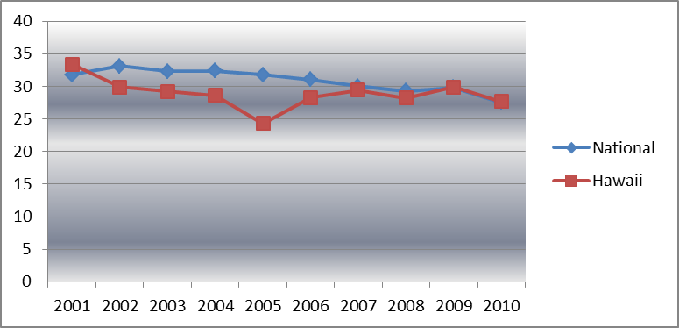
  Year | National | Hawai‘i
  2001 | 31.8 | 33.4
  2002 | 33.1 | 29.9
  2003 | 32.3 | 29.2
  2004 | 32.4 | 28.6
  2005 | 31.8 | 24.3
  2006 | 31.0 | 28.3
  2007 | 30.0 | 29.4
  2008 | 29.3 | 28.2
  2009 | 29.8 | 29.9
  2010 | 27.5 | 27.7

The CDC’s 2010 survey (NISVS) provides both national and state-level prevalence estimates of sexual violence. The study reported that nationally, one in five women (18.3%) and one in 71 men (1.4%) have been raped in their lifetime. Lifetime estimates for women ranged from 11.4% to 29.2% for rape and 28.9% to 58% for sexual violence other than rape. For men, lifetime estimates ranged from 10.8% to 33.7% for sexual violence other than rape; and 17.4% to 41.2% for rape, physical violence, and/or stalking by an intimate partner. For Hawai‘i, lifetime prevalence of sexual violence other than rape for women was 41.9% and for 17.1% for men. There was no available data on lifetime prevalence for rape . However, Ruggiero and Kilpatrick , drawing on a model using national factors predictive of female forcible rape, projected 14.5% of adult women in Hawai‘i have been subject to a completed forcible rape in their lifetime. This appears within the range of national statistics.

The prevalence of child sexual assault varies due to differences in definitions and methodology, but a conservative estimate of child sexual abuse prevalence is 20% in females and 5-10% in males. A recent meta-analysis of over 65 articles covering 22 countries revealed that approximately 8% of males and 20% of females suffered some type of sexual assault prior to the age of 18 . Finkelhor, Jones and Shattuck have tracked the trends in child maltreatment statistics collected by the U.S. federal government and found a national decline in the incidence of both physical and sexual abuse that began in the middle of the 1990s and continues through the present. While there is no consensus about the factors behind the decline, Finkelhor and his colleagues cite a number of potential reasons (e.g., prevention and social intervention, incarceration and treatment of offenders, higher thresholds for reporting, etc.) that may be related to the decline in the incidence of child sexual assault.

SECTION 2: DEMOGRAPHIC PROFILE

Victim Profile – Hawai‘i
In the 9.5 year period between 2001 and 2010, SATC served an average of 508 victims per year, ranging from 467 in 2004 to 562 in 2007. These numbers represent more than one victim per day seeking assistance and do not reflect the number of services each victim received or the length of time each victim remained in contact with the SATC.
Fluctuations in the number of victims assisted across time most likely reflects variable staffing ratios due to funding constraints rather than victim needs. Table 1 details demographics variables within the SATC population.

Age
For the current 10 year review, 58.2% of victims were minors. The average age of all victims combined was 18.65 years. The average age of a female victim receiving services at the SATC was 19.43 while the average age of a male victim was 13.19. However, as seen in Figure 2, the peak or modal age group for females was 12-15 years while for males it was 6-11 years.
Figure 3: Age Distribution of Female and Male Sexual Assault Victims
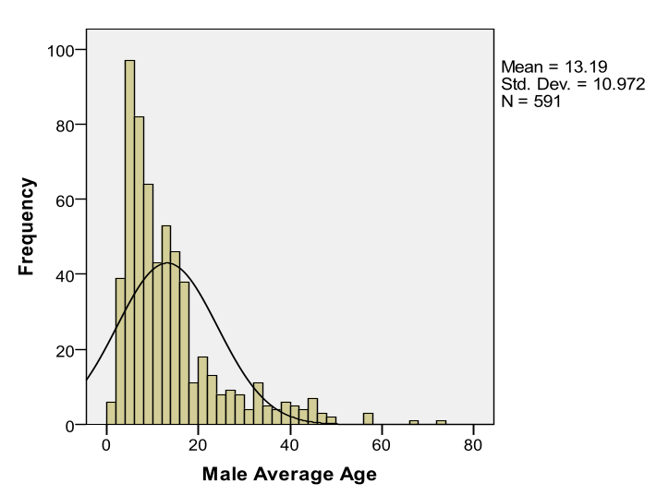 | 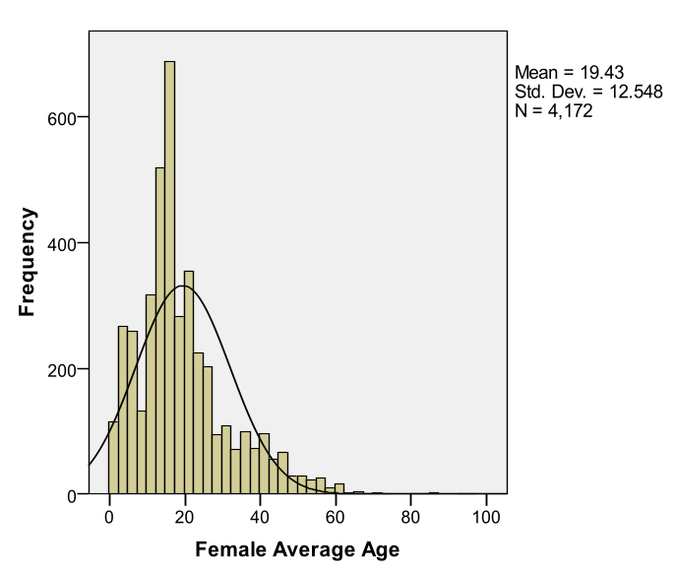
Table 1: Demographic Characteristics of Sexual Assault Victims Seeking Treatment at SATC, 2001-2010 (Percentages)
Demographic | All N=4,763 | Females N=4,172 | Males N=591
Age (in years)  0-5  6-11  12-15  16-17  18-22  23-29  30-45  46 and over | 13.1  13.4  22.4  9.1  14.2  11.6  12.0  4.3 | 11.6  10.8  23.2  9.4  15.3  12.5  12.6  4.7 | 24.0  32.0  16.8  6.4  6.3  5.1  7.8  1.7
Ethnicity  Hawaiian/part Hawaiian  Caucasian  Filipino  Japanese  Black  Samoan  Korean  Hispanic  Chinese  American Indian/Native Alaskan  Other Pacific Islander  Vietnamese  Other Asian (not mixed)  Other (Not mixed)  Mixed (non-Hawaiian) | 28.2  22.7  8.1  5.6  2.2  2.1  1.3  2.8  1.4  0.3  1.4  0.2  0.7  0.6  22.4 | 27.4  22.8  8.2  5.9  2.1  2.3  1.4  2.9  1.4  0.3  1.4  0.2  0.8  0.7  22.3 | 33.5  22.3  7.4  3.1  2.5  0.6  0.8  1.9  1.4  0.0  1.9  0.4  0.0  0.6  23.6
Marital Status (victims 18 and older)  Single  Married  Separated  Divorced  Widowed | 69.8  15.1  5.1  8.9  1.1 | 69.3  15.1  5.3  9.2  1.1 | 78.2  14.5  1.8  4.5  0.9
Employment Status (victims 18 and older)  Employed  Unemployed  Student  Retired | 51.7  21.8  25.4  1.1 | 51.6  21.6  25.9  0.9 | 53.4  25.0  18.2  3.4

Gender
During this decade, 87.6% of victims seen at the SATC were female while 12.4% were male. These figures do not reflect victims seen through domestic violence shelters because including this population would have artificially inflated the number of female victims seen. Both national prevalence rates and local statistical projections on prevalence indicate that significantly more females than males are victims of sex assault . In 2009, females compromised 90.8% of the SATC’s population, but a year later, in 2010, this had decreased to 85%, while the number of males serviced increased to nearly 15%.

Figure 4: Sex of Victim by Intake Year
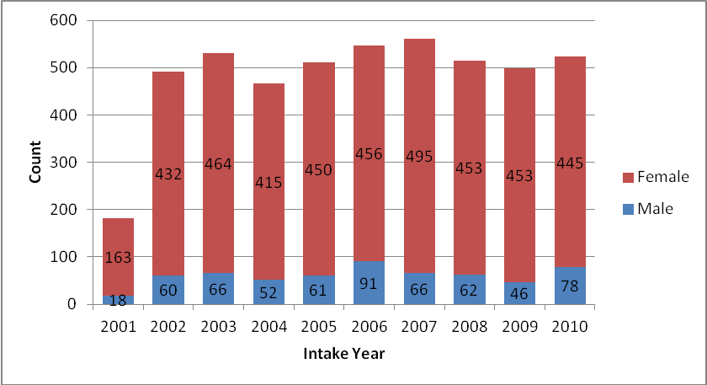

Age and Gender
In looking at the age of victims within gender categories, female victims were well distributed across all age categories up to 45 years or older with the highest percentage (23.2%) of victims in the 12 – 15 years category. In contrast, 56% of male victims were under 11 years of age. From age 12 years and older, few males sought services at SATC. Males were significantly younger than females (t (4761)=11.480, p<.000) with 73% of male victims under the age of 15 when they sought services at SATC as opposed to 45% of female victims who were under 15 years.
Ethnicity
According to the 2010 U.S. Census Bureau, Native Hawaiians and Other Pacific Islanders represented 9.5% of Honolulu’s total population . However, victims with Hawaiian/part-Hawaiian ancestry comprised 28.2% of victims served at SATC while 3.5% of the victims were Other Pacific Islanders. Thus, SATC serviced more victims who were Native Hawaiians and Other Pacific Islanders relative to other ethnic groups.
The percentage of Caucasian victims (22.7%) was roughly consistent with 22.2% of Caucasians residing in Honolulu per the 2010 census. Asian victims constituted 23.6% of victims served at SATC, although they comprised roughly 44% of Honolulu’s population. There was a large category of victims (22.4%) under the “Mixed Non-Hawaiian” heading who reflected the diverse multi-ethnic population of Hawaii. This is consistent with persons residing in Honolulu County and identifying as more than one race per the 2010 census (21.6%).
Marital and Job Status
The majority of adult victims were single (69.8%) and about half of victims were employed, while over 25% reported they were students. Among adult victims, 21.8% were unemployed. The SATC serves clients regardless of their ability to pay for services and is a resource for victims who may be indigent or uninsured.

Assault Characteristics –Hawai‘i
Relationship of Offender to Victim
The relationship of the offender to the victim was organized into 5 different categories as follows: intimate, family, acquaintance, authority figure, and stranger. The vast majority of victims reported they knew their perpetrator (83.1%) while stranger assaults accounted for 13.3% of all cases. Victims were assaulted by intimate partners in 10.5% of the cases and by family members in 29.2% of the sample. Assault by acquaintances was reported by 40.3% of victims. This data is consistent with national statistics which show that the most victims know their assailant .

By Gender: The overall female population at SATC was assaulted most frequently by acquaintances (40.4%), family members (27.9%) and strangers (13.9%). In contrast, male victims were significantly more like to be assaulted by family members (39.9%) followed by acquaintances (39.4%; χ² = 72.6, p<.000). Unlike female victims, male victims were nearly half as likely to be assaulted by strangers (8.2%), although this finding may have been influenced by the younger age of male victims in this sample. For female victims, assaults by intimate partners comprised about 12% of all assaults in contrast to less than 1% for male victims. Table 2 presents information on the relationship of the offender to the victim by age and gender.

Table 2: Relationship of Offender to Victim by Age and Gender
Relationship to Victim | Adult | Minor | Female | Male
Family | 12.8% | 42.8% | 27.9% | 39.9%
Acquaintance | 46.0% | 35.5% | 40.4% | 39.4%
Intimate | 16.1% | 5.3% | 11.3% | 0.6%
Stranger | 20.4% | 7.5% | 13.9% | 8.2%
Authority Figure | 4.7% | 8.9% | 6.4% | 11.9%

By Age: Victims 11 years and younger were more likely to be sexually assaulted by family members and to a lesser extent by acquaintances and authority figures. Even through the age of 15, victim assaults by family members constituted about a third of all assaults for this age category. Victims 16-17 were most likely to be attacked by acquaintances while victims 18 and older were assaulted most frequently by acquaintances as well as strangers. Table 3 presents the information on the relationship of the offender to the victim by age categories.

Table 3: Relationship of Assailant to Victim by Age Categories (Percentages)
Relationship | All (N = 3,279) | Females (N = 2,928) | Males (N = 353)
0 – 5 Years  Family  Authority Figure  Acquaintance  Stranger  Intimate | 62.5  15.8  20.6  1.5  0.0 | 65.1  15.9  16.9  2.0  0.0 | 53.4  13.6  33.0  0.0  0.0
6 - 11 Years  Family  Authority Figure  Acquaintance  Stranger  Intimate | 61.0  9.4  25.1  4.5  0.0 | 64.6  8.8  21.2  5.5  0.0 | 51.9  11.1  35.2  1.9  0.0
12 - 15 Years  Family  Authority Figure  Acquaintance  Stranger  Intimate | 29.8  6.0  45.6  9.5  9.2 | 29.7  5.9  45.2  9.3  9.9 | 30.2  7.5  50.9  11.3  0.0
16 - 17 Years  Family  Authority Figure  Acquaintance  Stranger  Intimate | 26.2  7.0  43.4  13.9  9.6 | 26.3  5.4  45.0  13.3  10.1 | --  --  --  --  --
18 - 22 Years  Family  Authority Figure  Acquaintance  Stranger  Intimate | 8.3  2.8  56.2  22.8  9.9 | 8.0  2.7  55.8  23.0  10.5 | --  --  --  --  --
23 - 29 Years  Family  Authority Figure  Acquaintance  Stranger  Intimate | 11.3  3.6  49.9  20.4  14.9 | 10.1  2.8  50.8  20.7  15.7 | --  --  --  --  --
30 - 45 Years  Family  Authority Figure  Acquaintance  Stranger  Intimate | 20.1  6.5  34.0  16.1  23.3 | 20.5  6.0  33.1  16.0  24.4 | --  --  --  --  --
46 and Over  Family  Authority Figure  Acquaintance  Stranger  Intimate | 14.5  11.3  27.4  23.4  23.4 | 13.4  11.8  26.9  23.5  24.4 | --  --  --  --  --

Time of Assault
For all victims, the majority of assaults occurred between midnight and 6 am (47.3%), although females were significantly more likely than male victims to be assaulted between midnight and 6:00 a.m. (χ² (3)= 11.645, p=.009) compared to other times of day. 26.6% of all assaults occurred during the 6 pm to midnight time frame for both females (27%) and males (22.3%). Figure 5 summarizes the time of assault by sex of victim.

Figure 5: Time of Assault by Gender
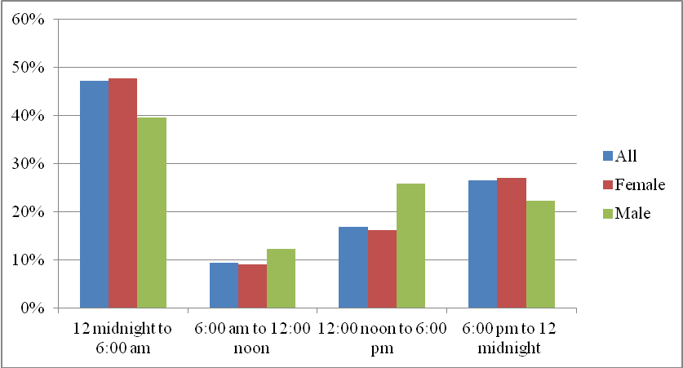
There are significant differences between the time of assault and the victim-assailant relationship (χ² (12)= 71.3, p<.000). Assaults by family members primarily occurred during midnight to 6:00 a.m. (37.7%) and between 6 pm to midnight (31.9%). Similarly, acquaintance assaults occurred most frequently from midnight to 6:00 a.m. which accounted for 48.5% of all acquaintance assaults. Stranger assaults also occurred most often in the midnight to 6:00 a.m. time frame (54.9%). Assaults by authority figures were more likely to occur between 6:00 a.m. and noon compared to other types of offenders. Figure 6 portrays the time of assault by the offender-victim relationship.

There was a significant difference in time of assault and the age of victim between adults and minors (χ²(3) = 144.1, p<.000). Children 11 years and younger were most likely to be assaulted between 12 noon and midnight and least likely to be assaulted between 6:00 a.m. and 12 noon. From 16 years and older, the majority of assaults occurred in the midnight to 6:00 a.m. period. Figure 6 summarizes the age of victim by time of assault.

Figure 6: Time of Assault by Offender-Victim Relationship
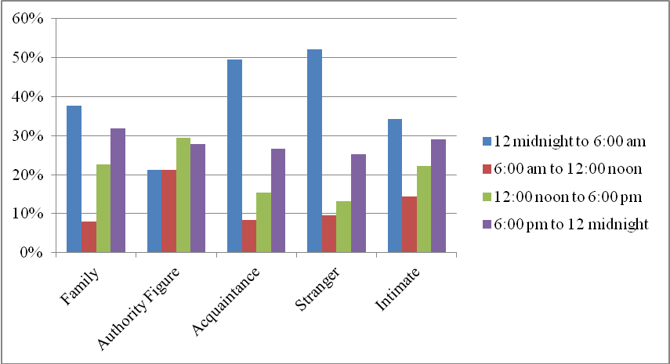

Location of Assault

For victims under the age of 5 and between the ages of 16 – 22 years, assaults occurred in both the victim’s and assailant’s home about an equal proportion of the time. In contrast, victims age 6 to 11 years tended to be assaulted much more frequently in their own homes. Victims 23 years and older were also more likely be assaulted in their homes.

For all victims, assaults occurred most frequently in the victim’s home, hotel or workplace (47.9%) followed by assaults in the assailant’s home, hotel or workplace (31.6%). This pattern was consistent for both sexes: although the location of assault by age (adult versus minor) did not significantly differ for males, it was significant for females (χ² (4)= 26.8, p<.000). Table 4 presents more detailed information about the location of assault by age by gender.

Table 4: Location of Assault, by Age and Gender (Percentages)
Location by Age at Assault | All (N=3,103) | Female (N=2,780) | Male (N=323)
0-5 Years  Victim’s home, hotel or workplace  Other private place  Outdoors  Assailant’s home, hotel or workplace  Other public place | 40.5  14.2  0.6  37.9  6.8 | 44.4  12.8  0.0  36.6  6.2 | 28.4  18.5  2.5  42.0  8.6
6 - 11 Years  Victim’s home, hotel or workplace  Other private place  Outdoors  Assailant’s home, hotel or workplace  Other public place | 53.2  8.7  0.3  27.5  10.4 | 55.2  9.3  0.4  27.0  8.1 | 48.0  7.1  0.0  28.6  16.3
12 - 15 Years  Victim’s home, hotel or workplace  Other private place  Outdoors  Assailant’s home, hotel or workplace  Other public place | 44.2  10.6  1.0  31.8  12.3 | 44.2  10.6  1.1  31.9  12.1 | 44.7  10.6  0.0  29.8  14.9
16 - 17 Years  Victim’s home, hotel or workplace  Other private place  Outdoors  Assailant’s home, hotel or workplace  Other public place | 39.6  11.6  0.7  33.2  14.9 | 40.1  11.7  4.3  33.2  14.2 | 33.3  9.5  0.0  33.3  23.8
18 - 22 Years  Victim’s home, hotel or workplace  Other private place  Outdoors  Assailant’s home, hotel or workplace  Other public place | 34.9  16.0  4.0  37.2  7.9 | 34.2  16.4  4.1  37.3  7.9 | 46.4  7.1  3.6  35.7  7.1
23 -29 Years  Victim’s home, hotel or workplace  Other private place  Outdoors  Assailant’s home, hotel or workplace  Other public place | 43.0  14.1  2.6  32.7  7.6 | 43.1  14.1  2.3  33.0  7.6 | 40.9  13.6  9.1  27.3  9.1
30 - 45 Years  Victim’s home, hotel or workplace  Other private place  Outdoors  Assailant’s home, hotel or workplace  Other public place | 54.6  10.3  1.9  25.7  7.4 | 56.3  10.1  1.7  25.6  6.2 | 27.3  13.6  4.5  27.3  27.3
46 and Over  Victim’s home, hotel or workplace  Other private place  Outdoors  Assailant’s home, hotel or workplace  Other public place | 62.9  12.9  0.8  12.9  10.6 | 62.5  12.5  0.8  13.3  10.9 | --  --  --  --  --

Assault Strategies
The SATC collects data, when available, about techniques that assailants use when perpetrating sexual violence. A threat implies any verbal statement or act from the perpetrators which shows an intention to inflict an injury upon the victim. Victims are often fooled, tricked or manipulated by the perpetrator into sexual activity. Through this type of deception, the perpetrator may elicit or gain the victim's “compliance”. Data is also collected on whether the victim was injured and whether weapons were used in the assault. Intimidation strategies include any intentional behavior which causes a victim fear or discomfort (e.g., unwelcome sexual advances, requests for sexual favors, stalking, cyberstalking, etc.).
The data for this section need to be qualified because most of the time, the information was not available at the time of intake. The results are therefore based on the smaller pool of victims who disclosed the use of specific strategies upon intake. Data are missing on assault strategies for 50-75% of all cases. Despite a smaller sample, certain patterns emerged. For example, weapons were used in less than 10% of the cases reviewed although injuries were evident about 25% of the time. Deception was reported in only about 15.5% of cases while threats were used in 37.1% of cases. Intimidation was noted in over half of the cases (58.8%).

Assailants used threats against both female and male victims an equal percent of the time (37.3% vs. 34.6%). Weapons were rarely used for either sex (9.4% for females, 9.0% for males) although injuries were slightly more prevalent for females (24.8%) as opposed to males (18.1%). The use of deception was slightly higher for males (18.2%) than females (15.3%), while the offender used intimidation more frequently with females (59.5%) than for males (51.1%). Figure 7 presents the information on those victims reporting use of specific assailant strategies.

Figure 7: Percent of Victims Exposed to Assailant Strategies by Gender
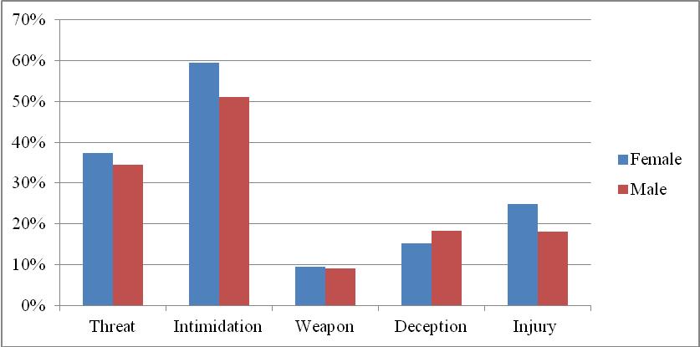

Across age categories, assailants used intimidation more than half of the time to gain control of their victims. This was true even for younger victims and this finding may partially reflect the type of population serviced. Many of the minors seen at the SATC do not fall under the jurisdiction of child welfare where a family or household member is the offender. Family members who are perpetrators can gradually groom younger children over a long period of time so that when the offender is ready to commit a sexual offense, intimidation may not be needed. SATC tends to service cases in which the perpetrator is non-familial and under this scenario, assailants may not have had sufficient time to initiate the grooming process and thus resorted to more direct strategies to subdue victims.
Physical injuries were most common among adults and increased with age. Similarly, the use of weapons increased with victim age. The use of assault strategies by age of victim is reported in Table 5.

Table 5: Assailant Assault Strategies by Age at Assault (Percentages)
 | Strategy
Age | Threat | Deception | Injury | Intimidation | Weapon
0–5 | 20.0 | 10.3 | 15.3 | 54.3 | 6.6
6-11 | 38.9 | 24.5 | 13.0 | 65.6 | 3.6
12-15 | 31.9 | 12.3 | 13.1 | 53.7 | 7.0
16-17 | 33.2 | 8.0 | 19.9 | 55.8 | 9.0
18-22 | 33.5 | 17.3 | 30.8 | 55.1 | 9.5
23-29 | 39.9 | 23.8 | 30.7 | 59.9 | 9.7
30-45 | 50.5 | 13.4 | 38.4 | 67.9 | 15.1
46+ | 53.3 | 11.8 | 41.7 | 78.0 | 17.6

Referrals to SATC
For females under 11 years of age, the most common referral sources were social service agencies and medical personnel. Referrals by social service agencies were much more common among minors under the age of 18. Compared to female victims, male victims were typically more likely to be referred by family members. The police were the most frequent referral source accounting for 34.7% of all referrals. The SATC has a collaborative working relationship with the Honolulu Police Department, so it is not surprising that across all victims, they were the source that most frequently referred victims to the SATC. Referral source information is provided in Table 6.

Table 6: Referral to SATC by Age and Gender (Percentages)
Referral by Age at Assault | All | Females (n=3217) | Males (n=367)
0 – 11 Years (n=850)  Police  Family  Friends  Self  Physician/hospital/ambulance  Social service agency  Work/school  Other | 23.5  5.8  1.5  1.6  31.3  27.1  4.4  4.8 | 22.5  5.2  1.4  1.7  32.7  28.2  3.9  4.5 | 26.9  7.5  2.0  1.5  26.9  23.4  6.0  6.0
12-17 Years (n=1093)  Police  Family  Friends  Self  Physician/hospital/ambulance  Social service agency  Work/school  Other | 40.1  8.3  2.4  1.6  15.3  20.4  7.1  4.8 | 40.6  8.2  2.5  1.8  14.9  20.5  7.0  4.5 | 33.8  10.0  1.3  0.0  20.0  18.8  8.8  7.5
18-29 Years (n=1048)  Police  Family  Friends  Self  Physician/hospital/ambulance  Social service agency  Work/school  Other | 38.6  5.2  9.6  2.3  20.9  6.8  6.9  9.7 | 38.9  4.4  9.6  2.3  21.3  7.2  6.8  9.6 | 33.9  17.9  10.7  1.8  14.3  0.0  8.9  12.5
30 and Over (n=602)  Police  Family  Friends  Self  Physician/hospital/ambulance  Social service agency  Work/school  Other | 33.6  4.8  5.5  3.7  21.8  12.5  2.5  15.4 | 35.2  4.8  5.3  3.7  21.3  12.8  2.5  14.4 | --  --  --  --  --  --  --  --
All  Police  Family  Friends  Self  Physician/hospital/ambulance  Social service agency  Work/school  Other | 34.7  6.2  4.8  2.2  21.8  16.7  5.6  8.0 | 35.5  5.8  4.9  2.3  21.5  16.6  5.5  7.8 | 27.9  9.2  3.7  1.3  24.2  17.1  6.6  10.0

SECTION 3: TRENDS

Introduction
From 2001 to 2010, the ratio of female to male victims receiving SATC services remained fairly constant. The majority of victims seen at the SATC during the most recent 10 year reporting period were female (87.4%), as opposed to male (12.4%). The greatest number of males were served in 2006 (n = 91, 16.6%) followed by 2010 (n=78, 14.9%). Consistent with prior findings, roughly nine out of ten of SATC’s population in any given year is female.
Figure 8: Percent of Victims by Gender
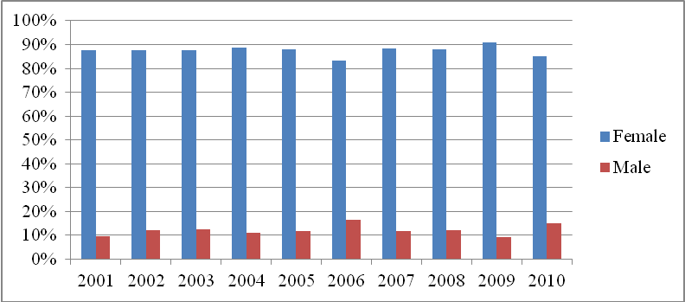

Age and Gender
In the current 10 year review, 57.2% of victims served were minors. Although the average age of victims seen at SATC was 18.65 years, a breakdown by gender revealed that the average age of males was consistently younger than females across the time span (refer to Figure 9). The greatest disparity occurred in 2004 where the average age of female victims was 17.98 in contrast to 10.06 for males, followed by 2010 in which females’ average age was 21.27 while the mean age of males was 13.78.

Figure 9: Victim Age at Assault by Gender 2001-2010
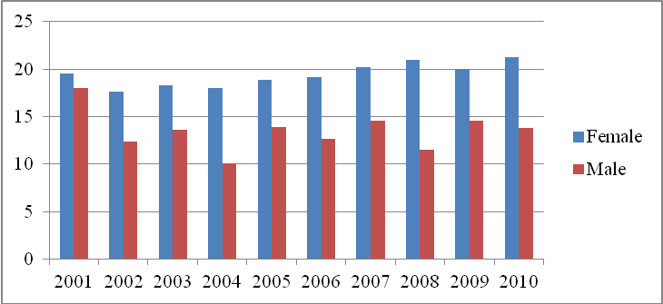
Note: Increase in male age in 2001 may be due to smaller n.

Ethnicity
Across the 2001 to 2010 time period, Hawaiians and part-Hawaiians constituted the largest ethnic group served (28.2%) followed by Caucasians (22.7%) and those with mixed non-Hawaiian ancestry (22.4%). These 3 ethnic categories combined accounted for nearly three-fourths (73.3%) of SATC’s population and this ethnic pattern was consistent across the 9.5 year time period. For the current reporting period there were more victims within the mixed ethnicity category than in previous years, but overall ethnicity trends in victims served were consistent with findings from the previous 10 years. Though the “other” category shows a gradual increase across the decennial, this category is not representative of any particular ethnocultural trends as it is composed of multiple ethnic categories (see Appendix B). However, the overall percentage of Hawaiian/part-Hawaiian victims seen through SATC does seem to have decreased relative to the prior 10 year period, while the percentage of clients who are of mixed ancestry but with no Hawaiian blood has increased. Nonetheless, as illustrated in Figure 10, Hawaiians/part-Hawaiians continue to be the largest single ethnic group in SATC’s population.

Figure 10: Ethnicity of Victims 2001-2010
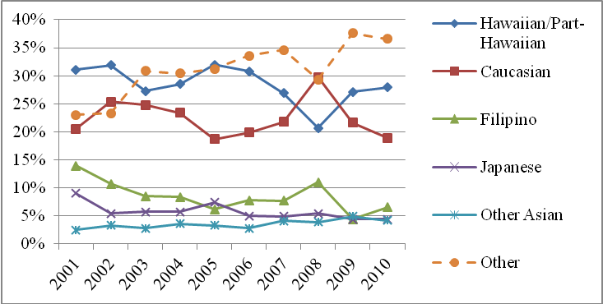
Relationship of Offender to Victim
Gender: For women, a majority of victims identified the offender as an acquaintance. However, there was a trend towards increased stranger assaults over time with a notable increase in stranger assaults in the years 2008-2009. This does not necessarily mean that stranger assaults were increasing, but rather that victims may have been more willing to seek help when the assailant was a stranger. As seen in Figure 11, offenders who were a family member, acquaintance or stranger accounted for the majority of female assaults.
Figure 11: Female Victim-Assailant Relationship 2001-2010 (n=4226)
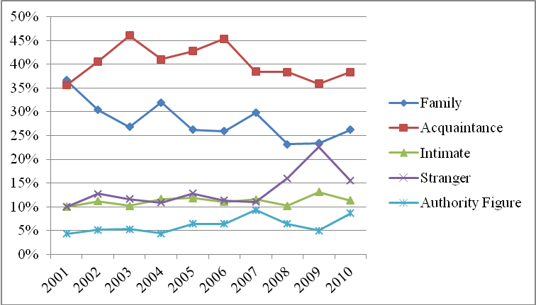
There was some fluctuation in assailants that males identified as acquaintances over the 9.5 year period, which may be due to lower numbers of cases. Notably, male victims were significantly younger than female victims and, compared to females, had few offenders indentified as intimate partners. Similarly, while 13.9% of females reported assaults by strangers, the figure for males was 8.2%. Overall, perhaps because male survivors seeking services at SATC tended to be younger, family members or acquaintances were identified as the assailants in a 79.3% of cases as seen in Figure 12.

Figure 12: Male Victim-Assailant Relationship 2001-2010 (n=353)
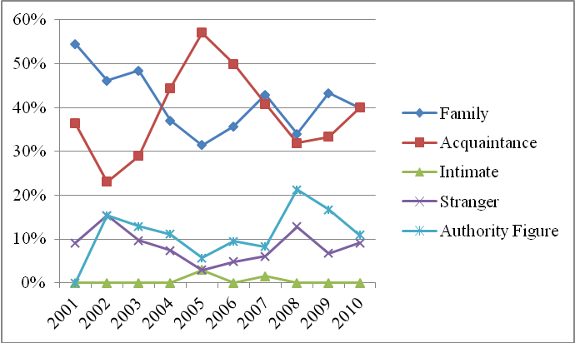

Age Status: Compared to adults, minors were less likely to be assaulted by strangers and twice as likely to be assaulted by family members (see Table 3 page 19). There were no significant trends by year in victim-assailant relationships by age.

Location of Assault
Female victims tended to be assaulted in their own home, hotel or workplace far more often than any other location (average of 45.2% of the time). This was closely followed by assaults in the assailant’s home, hotel or workplace (average of 31.6% of the time). While male victim assaults also occurred primarily in the home setting (40.3%), there were significant fluctuations from year to year. This variability also held true for assaults in the assailant’s home, hotel or workplace (32.3%). For both adults and minors, assaults took place most frequently in the victim’s home, followed by the assailant’s home. For minors, there was an increasing trend of assaults occurring in public places over the 9.5 year period. Table 7 provides a breakdown of locations of assault for the entire 9.5 year period comparing females and male as well as adults and minors.

Table 7: Location of Assault by Gender and Age
 | Female | Male | Adult | Minor
Victims home, hotel or workplace | 45.2% | 40.3% | 44.8% | 44.6%
Other private place | 12.4% | 11.7% | 13.6% | 11.2%
Outdoors | 1.7% | 1.8% | 2.8% | 0.7%
Assailants home, hotel or workplace | 31.6% | 32.3% | 30.9% | 32.3%
Other public place | 9.2% | 13.8% | 8.0% | 11.2%

Time of Assault
Across the 10 year time span, female victims were predominantly assaulted during the midnight to 6:00 a.m. time period, followed by 6:00 p.m. to midnight. Due to a high number of missing cases, time of assault for male victims was not analyzed. Adults were more likely to be assaulted between midnight and 6 a.m. relative to the other time frames (Figure 13) while there was much more variability in time of assault for minors over the 10 year time period (Figure 14).

Figure 13: Time of Assault for Adult Victims 2001-2010  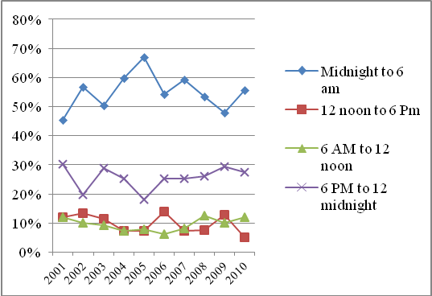 | Figure 14: Time of Assault for Minor Victims 2001-2010  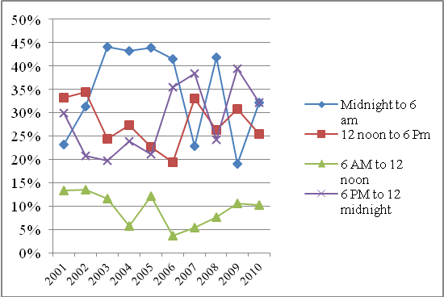

Police Reporting
Gender: Over the 9.5 year period, reports to police were made by 61.3% of male victims and 62.9% of female victims (Figure 15). There was a gradual decline in reporting to police. Male victims seen in 2010 police reported only 43.6% of the time with the overall
reporting percentage for females slowly trending downwards. Changes in police reporting may correspond with mandatory reporting laws, sources of referrals, and victim age.
Figure 15: Reports to Police by Gender 2001-2010
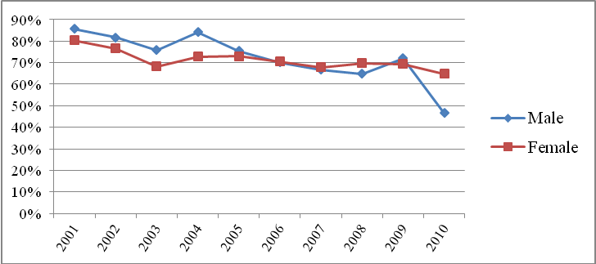
Age: In looking at police reports by adult versus juvenile status in Figure 16, adults reported an average of 61.6% of the time while minors reported an average of 77.7% of the time. While reporting percentages are still significantly above national averages, there is a downward trend over the 10 year span which may reflect the challenges inherent in obtaining criminal justice outcomes in sexual assault cases and/or a tendency for survivors who seek SATC services to choose not to involve law enforcement.
Figure 16: Percent of Victims Reporting to the Police by Age Status, 2001-2010
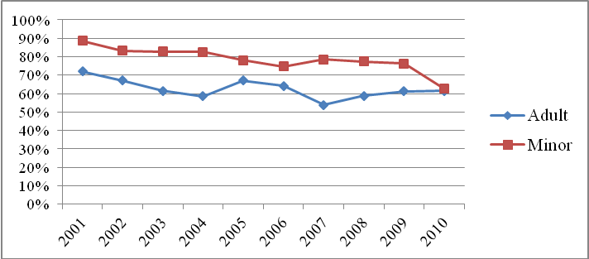

SECTION 4: VICTIM POLICE REPORTING

Background

This section will explore variables associated with reporting sexual assault to the police. Historically, sexual assault is widely recognized as the most underreported crime in the United States . It is estimated that 16% to 20% percent of victims of sexual assault report the crime . Furthermore, despite policy change and increased awareness of the issues, reporting has not significantly increased since the 1990s and remains steady around 17% . Victim concerns about the impact of reporting, societal attitudes about rape, access and barriers to care and other factors can influence a person’s decision to report .

Reporting rape and sexual assault can have significant personal and societal implications. Individuals who report are more likely to have access to healthcare and legal services, which is of particular importance as sexual assault can have many detrimental impacts. Zinzow and colleagues found that reporting to police significantly increased the likelihood of accessing post-rape medical attention.

Issues that have been associated with a hesitance to report an assault include: not feeling the assault was serious enough, shame, fear others would find out, fear of reprisal from the offender and feeling that nothing could be done . In some instances, such as in acquaintance rape, the victim may not label what occurred as a sexual assault. Naturally, psychosocial factors impacting reporting, such as fear and distrust, are related to both victim demographics and assault characteristics. Consequently, differences in assault type and characteristics, referral sources, victim-assailant relationship, gender and ethnicity are all factors that can influence police reporting trends. Additionally, statistics in reporting may vary based on the sample. Within the SATC cases, 71.1% of cases reported their assault to the police.

Assault Characteristics
Several incident characteristics have been found to be related to police reporting behavior. Use of alcohol or drugs at the time of assault by the victim has been associated with lower rates of reporting . The use of a weapon by the assailant or injury occurring to the victim is associated with higher likelihood of reporting .

Victim-Assailant Relationship
In a study conducted by Jones, Alexander, Wynn, Rossman, & Dunnuck , victims citing “I know the assailant” as a primary reason for not reporting were significantly less likely to file a police report. Correspondingly, extant research has identified that victims who are assaulted by someone they know are less likely to file a police report .

Victim Demographics
Ethnicity, education attainment and marital status of the victim have all been found to be related to reporting . However, the effects of race/ethnicity on police reporting are not clear. First, many large national surveys, require that Asian Americans and Native Hawaiians/Pacific Islanders self-identify as one “Asian American/Pacific Islander” group . Because Asian American and Pacific Islanders are distinctly different in their cultural make-up , combining both groups does not accurately identify the unique attributes or trends within each subgroup. For example, Wolitzky-Taylor et al. (2011) found that women in the “other” category comprised of Asian, Native American and Pacific Islander were four times more likely to report when compared to White women. Alternatively, a 2000 study with a diverse sample allowing for the separation of subgroups, found that Japanese women were less likely to report to the police than all other ethnicities including Caucasian women. Though cultural differences may impact reporting, the varying results reported in empirical research leads to inconclusive findings for ethnic trends in police reporting.

Reporting Behavior in Honolulu
A majority of survivors receiving services at SATC reported the incident to the police (62.2%, n=4230). While seeking services may have an influence on one’s decision to report, over one-third of those seeking services did not report (or the information was not noted on their file). Examining reporters versus non-reporters may provide crucial information for handling sexual assault. Reporting may be unusually higher than national averages in this sample as nearly one-third were referred by the police and are treatment seeking, which may the increase likelihood of reporting.

There was only a small difference in reporting by gender (Table 8), however cases involving minors were more likely to report than cases with adults (Table 9). Additionally, 75.2% of adult victims who were assaulted within the past 72 hours police reported as opposed to only 33.9% of adults whose assaults occurred in the past. In contrast, assaults against minors tended to more consistently reported regardless of whether the assault fell within the 72 hour time frame (74.6%) or in the past (79.4%).

Table 8: Percentage of Victims Reporting to the Police, by Age and Gender
 | Percent Reporting to the Police
Age*  Juvenile  Adult | 77.7%  61.6%
Gender  Male  Female | 69.2%  71.4%
Note: *Denotes statistical significance at p<.05.

Table 9: Police Reporting by Age and Case Type
 | Non-Acute | Acute
Minor | 79.4% | 74.6%
Adult | 33.9% | 75.2%

Predictors for Reporting to Police - Adults
There were several factors that influenced the likelihood of adults reporting sexual assault to the police (see Table 10). The assailant-victim relationship significantly impacted victim reporting in two ways. Adults were most likely to report if the assailant was a stranger and least likely to report if the assailant was a family member (χ²(4)=106.96, p<.000). This is consistent with past research which shows that “classic rape” or the stereotypic assault by a stranger is reported at higher rates. Adult victims were also more likely to report if there was only one assailant as opposed to multiple assailants. Victims
who were sexually assaulted with an object were most likely to report followed by forcible sodomy. However, it should be noted that fewer cases provided information about these incidences. Several characteristics about the assault influenced reporting. If the assailant used a weapon, intimidation, physical force, threat or injured the victim, reporting increased. Reporting was highest when the victim was injured. The location of the assault also significantly influenced the decision to report (i.e., if the assault took place outdoors).

Examining victim demographics revealed other trends in reporting. Other Asian (excluding Japanese and Filipino) were the least likely to report sexual assault. There was little variance in the reporting rates of other ethnicities in contrast to former years when Native Hawaiian/Part-Hawaiian victims were more likely to report. Gender differences were most prominent in adults with only 39.6% of males reporting compared to 63.0% of women. Males were significantly less likely to report sexual assault to the police (χ² (2)=23.065, p<.000). Naturally, victims referred to SATC by the police were most likely to report (95.8%). Alternatively, victims referred by friends were least likely to report (32.4%).

In summary, examining the correlates in adult victim reporting showed that similar to national statistics, victims were most likely to report in cases of “classic rape” when the assailant was a stranger, the assault occurred outdoors and threat or physical harm was involved.

Table 10: Adult Victim Reporting Behavior (Percentages) n=1724
 | Reported to Law Enforcement | Did Not Report to Law Enforcement
Location of Assault  Victims Home, Hotel or Workplace  Assailants Home, Hotel or Workplace  Other Private Place  Outdoors  Other Public Place | 65.5  66.1  60.6  74.4  68.0 | 34.5  33.9  39.4  25.6  31.3
Relationship of Victim to Assailant  Family  Authority Figure  Acquaintance  Stranger  Intimate | 32.5  65.1  68.4  77.1  70.8 | 67.5  34.9  31.6  22.9  29.2
Number of Assailants  One  Two or more | 67.0  57.2 | 33.0  42.8
Assault Characteristics  Assailant Threatened Victim**  No threat  Assailant Used Physical Force**  No Physical Force  Assailant used a weapon**  No Weapon  Assailant used Intimidation**  No Intimidation  Assailant used Deception  No Deception  Assailant injured victim**  No injury | 75.8  67.9  74.8  62.5  82.1  68.3  81.8  70.9  75.0  76.7  84.0  67.2 | 24.2  32.1  25.2  37.5  17.9  31.7  18.2  29.1  25.0  23.3  16.0  32.8
Type of Assault  Forcible rape  Forcible Sodomy (n=455)  Sexual Assault with an Object (n=51)  Forcible Fondling  Other Sexual Assault | 72.1  77.8  80.4  75.7  75.7 | 27.9  22.2  19.6  24.3  24.3
Ethnicity  Hawaiian/Part-Hawaiian  Caucasian  Filipino  Japanese  Other Asian  Other | 64.5  63.1  63.3  59.2  49.4  59.9 | 35.5  36.9  36.7  40.8  50.6  40.1
Gender  Male  Female | 39.6  63.0 | 60.4  39.6
Marital Status¹  Single  Married  Separated  Divorced  Widowed | 61.5  58.5  60.5  56.7  73.7 | 38.5  41.5  39.5  43.3  26.3
SATC Case Type  Acute  Nonacute | 61.9  58.0 | 38.1  42.0
Referral to SATC  Police  Family  Friends  Self  Physician, Hospital, or Ambulance  Social Service Agency  Other  Work/School | 95.8  40.5  32.4  56.1  52.7  41.3  37.0  58.4 | 4.2  59.5  67.6  43.9  47.3  58.7  63.0  41.6
Note: *Denotes statistical significance at p<.05, **Denotes statistical significance at p<.01, ¹ Marital status excludes minors.

Predictors for Reporting to Police - Juveniles
Dissimilar from the previous 10 years, there was a statistically significant difference in reporting rates for minor victims compared to adult victims (see Table 11). About 8 out of 10 victims were reported to law enforcement regardless of the number of assailants or the relationship of the victim to assailant. In contrast to adults, juvenile victims commonly reported regardless of whether the assailant was a family member, stranger, intimate partner or acquaintance, with little variation among the relationship of victim to assailant. There was, however, a smaller percentage of juvenile victims reporting if the assailant was an authority figure (74.5%).

Victims were least likely to report if the assault occurred in a home, hotel or workplace, either the victim’s or assailant’s, and most likely to report if the assault occurred in another private place such as a parking garage or neutral home. The use of threat, a weapon or intimidation significantly impacted a victim’s decision to report with individuals experiencing those assault tactics more likely to report. Overall, about 84% of juvenile victims reporting specifics on the assault type reported regardless of the type of assault. There was considerable overlap here as only about half the sample reported the type of assault they experienced.

Caucasian, Filipino and Japanese victims were most likely to report to the police. Similar to adult victims, Other Asian victims were least likely to report (64.9%). Gender did not impact police reporting in juveniles. Individuals referred by friends and family were the least likely to file a police report. Naturally, nearly all (97%) of victims who were referred by the police filed a report.

Table 11: Juvenile Victim Reporting Behavior (Percentages) N=2493
 | Reported to Law Enforcement | Did Not Report to Law Enforcement
Location of Assault  Victims Home, Hotel or Workplace  Other Private Place  Outdoors  Assailants Home, Hotel or Workplace  Other Public Place | 79.9  76.2  91.7  77.8  81.9 | 20.1  23.8  8.3  22.2  18.1
Relationship of Victim to Assailant*  Family  Authority Figure  Acquaintance  Stranger  Intimate | 78.3  74.5  80.1  79.2  77.3 | 21.7  25.5  19.9  20.8  22.7
Number of Assailants  One  Two or more | 79.4  78.8 | 20.6  21.2
Assault Characteristics  Assailant Threatened Victim  No threat  Assailant Used Physical Force  No Physical Force  Assailant used a weapon  No Weapon  Assailant used Intimidation  No Intimidation  Assailant used Deception  No Deception  Assailant injured victim  No injury | 87.9  77.3  82.9  77.6  82.6  79.6  86.9  76.4  91.8  80.4  83.2  80.1 | 12.1  22.7  17.1  22.4  17.4  20.4  13.1  23.6  8.2  19.6  16.8  19.9
Type of Assault  Forcible rape  Forcible Sodomy  Sexual Assault with an Object  Forcible Fondling  Other Sexual Assault | 84.6  84.8  84.2  84.3  84.8 | 15.4  15.2  15.8  15.7  15.2
Ethnicity  Hawaiian/Part-Hawaiian  Caucasian  Filipino  Japanese  Other Asian  Other | 77.4  82.2  82.5  83.3  64.9  77.4 | 22.6  17.8  17.5  16.7  35.1  22.6
Gender  Male  Female | 76.8  77.9 | 22.1  23.2
SATC Case Type  Acute  Nonacute | 71.2  69.8 | 28.8  30.2
Referral to SATC  Police  Family  Friends  Self  Physician, Hospital, or Ambulance  Social Service Agency  Other  Work/School | 97.9  57.3  48.6  62.1  54.1  75.5  59.8  69.2 | 2.1  42.7  51.4  37.9  45.9  24.5  40.2  30.8
Note: *Denotes statistical significance at p<.05, **Denotes statistical significance at p<.01.

Predictors for Reporting - Males
There were considerably fewer cases available for analysis for male victims. Consequently, few trends revealed are of statistical significance. Similar to national trends, males were significantly more likely to report if the assault resulted in injury or if the assailant used force, threat or intimidation. Additionally, there were significant trends in reporting to police if the assault type was sodomy, rape or forcible fondling. While these findings were consistent with trends in other subgroups, small sample sizes in ‘other sexual assault’ and ‘sexual assault with an object’ categories may limit the ability to identify significant trends between reporters and non-reporters. Of particular importance was that there were no identified cases of sexual abuse by an intimate partner, most likely due to the younger age of male victims in this sample. Police reporting did not differ by number of assailants or location of assault.

Very few trends were identified in male victim demographics. Police reporting did not vary by race/ethnicity. Consistent with information reported above, male juveniles were significantly more likely to report than male adults. Single men were significantly more likely to report an assault than their married counterparts, however, a majority of the single male victims included in the analysis were juveniles. Male survivors were most likely to report if they were referred to SATC by police and least likely to report if referred by a friend.

Table 12: Male Victim Reporting Behavior (Percentages) N=533
 | Reported to Law Enforcement | Did Not Report to Law Enforcement
Location of Assault**  Victims Home, Hotel or Workplace  Other Private Place  Outdoors  Assailants Home, Hotel or Workplace  Other Public Place | 68.1  62.5  40.0  84.2  67.6 | 31.9  37.5  60.0  15.8  32.4
Relationship of Victim to Assailant  Family  Authority Figure  Acquaintance  Stranger  Intimate¹ | 68.3  71.4  68.6  85.2  -- | 31.7  38.6  31.2  14.8  --
Number of Assailants  One  Two or more | 70.5  64.1 | 29.5  35.9
Age**  Adult  Minor | 39.6  76.8 | 60.4  23.2
Assault Characteristics  Assailant Threatened Victim**  No threat  Assailant Used Physical Force**  No Physical Force  Assailant used a weapon**  No Weapon  Assailant used Intimidation**  No Intimidation  Assailant used Deception  No Deception  Assailant injured victim**  No injury | 86.8  64.2  82.9  66.2  94.1  68.7  86.4  59.5  90.9  64.7  92.0  65.5 | 13.2  35.8  33.8  17.1  5.9  31.3  13.6  40.5  9.1  35.3  8.0  34.5
Type of Assault  Forcible rape**  Forcible Sodomy*  Sexual Assault with an Object  Forcible Fondling **  Other Sexual Assault | 64.3  76.0  78.6  76.7  61.6 | 35.7  24.0  21.4  23.3  37.4
Ethnicity  Hawaiian/Part-Hawaiian  Caucasian  Filipino  Japanese  Other Asian  Other | 69.8  71.3  80.6  64.3  60.0  65.5 | 30.2  28.7  19.4  35.7  40.0  34.5
SATC Case Type  Acute  Nonacute | 68.6  77.5 | 31.4  22.5
Referral to SATC**  Police  Family  Friends  Self  Physician, Hospital, or Ambulance  Social Service Agency  Other  Work/School | 94.2  43.8  35.7  50.0  44.3  76.4  36.4  60.9 | 5.8  56.3  64.3  50.0  55.7  23.6  63.6  39.1
Marital Status²*  Single  Married  Separated  Divorced  Widowed | 44.0  6.7  --  --  -- | 56.0  93.3  --  --  --
Note: *Denotes statistical significance at p<.05, **Denotes statistical significance at p<.01, ¹ Omitted percentages for variables with less than 5 cases, ² Marital status excludes minors.

Predictors of Reporting to Police - Females
There were few significant trends in police reporting between and within assault characteristics and victim demographics for females.

Female victims were most likely to report if they were assaulted by a stranger. More than three-fourths (77.2%) of victims who were assaulted by a stranger reported. However, as opposed to male victims, female victims were just as likely to report regardless of the relationship between victim and assailant. Furthermore, female victims reported about 75% of the time, no matter where the assault occurred or who committed the assault. Female victims were more likely to report if there was only one assailant. Consistent with previous research, females were more likely to report if there was force, intimidation, a weapon was used, or injury occurred. It is important to note here that several assailants used multiple methods.

Minors were more likely to report than adults, however the gap between minor and adult reporting lessens in female victims than with males. Whereas only 39.6% of adult males reported, 63.0% of adult females filed a police report. As with male victims, female victims were most likely to report if they were referred to SATC by police and least likely to report if referred by a friend.

Table 13: Female Victim Reporting Behavior (Percentages) n=3696
 | Reported to Law Enforcement | Did Not Report to Law Enforcement
Location of Assault  Victims Home, Hotel or Workplace  Other Private Place  Outdoors  Assailants Home, Hotel or Workplace  Other Public Place | 73.6  72.0  72.5  75.3  78.0 | 26.4  28.0  27.5  24.7  22.0
Relationship of Victim to Assailant  Family  Authority Figure  Acquaintance  Stranger  Intimate | 69.5  71.6  75.0  77.2  73.2 | 30.5  28.4  25.0  22.8  26.8
Number of Assailants  One  Two or more | 74.3  67.7 | 25.7  32.3
Age  Adult  Minor | 63.0  77.9 | 37.0  22.1
Assault Characteristics  Assailant Threatened Victim**  No threat  Assailant Used Physical Force*  No Physical Force  Assailant used a weapon  No Weapon *  Assailant used Intimidation**  No Intimidation  Assailant used Deception  No Deception  Assailant injured victim**  No injury | 80.0  73.3  77.4  72.5  81.2  74.4  84.0  75.2  80.7  79.7  83.1  75.7 | 20.0  26.7  22.6  27.5  18.8  25.6  16.0  24.8  20.3  19.3  16.9  24.3
Type of Assault  Forcible rape**  Forcible Sodomy**  Sexual Assault with an Object  Forcible Fondling **  Other Sexual Assault** | 77.8  82.5  82.7  81.0  71.9 | 22.2  17.5  17.3  19.0  28.1
Ethnicity  Hawaiian/Part-Hawaiian  Caucasian  Filipino  Japanese  Other Asian  Other | 74.6  70.0  75.4  65.5  55.3  71.5 | 25.4  30.0  24.6  34.5  44.7  28.5
SATC Case Type  Acute  Nonacute | 71.6  68.9 | 28.4  31.1
Referral to SATC  Police  Family  Friends  Self  Physician, Hospital, or Ambulance  Social Service Agency  Other  Work/School | 97.2  52.4  36.6  59.1  54.7  66.3  45.8  65.4 | 2.8  47.6  63.4  40.9  45.3  33.7  54.2  34.6
Marital Status¹*  Single  Married  Separated  Divorced  Widowed | 62.8  62.0  60.8  58.0  72.2 | 37.2  38.0  39.2  42.0  27.8
Note: *Denotes statistical significance at p<.05, **Denotes statistical significance at p<.01, ¹ Marital status excludes minors.

SECTION 5: ALCOHOL AND LEVEL OF ASSAULT RISK

Background

In up to 50% of cases of sexual assault, the victim, the perpetrator or both had consumed alcohol . This is especially concerning as alcohol consumption disrupts higher order cognitive processes and makes it difficult for the drinker to interpret complex stimuli such as social intent or social cues. While the impact of alcohol use can vary, certain trends have been identified in sexual assault where alcohol use was present.

The frequency of alcohol use during sexual assault, especially in adults, suggests there may be a correlation in some sexual assaults . Several studies have examined how assailant alcohol use may be associated with sexual assault. Zawicki and colleagues found that while perpetrators who used alcohol did not differ from perpetrators who had not used alcohol in terms of overall monthly alcohol use, they were more likely to endorse rape myth acceptance, “held stronger beliefs that alcohol increases their own sex drive, and believed more strongly that a woman’s drinking is a signal of sexual interest” (pg. 376). Furthermore, Parkhill, Abbey and Jacquest-Tiura’s study confirmed findings from previous studies that men who consume alcohol during a sexual assault may miss or ignore signs of victim resistance because they are focused on their own sexual arousal.

Alcohol use on the part of both the victim and/or assailant has been associated with certain assault characteristics and post-assault trends. Assailant alcohol use has been shown to increase the likelihood of the victim sustaining injuries as well as a greater likelihood of completed rapes .Victims are more likely to have interruptions in regular functioning (e.g., time lost from school, work, and recreational activities) when the perpetrator was using alcohol or drugs . Finally, victims who consumed alcohol or took drugs at the time of assault were significantly less likely to report the crime . Taken together, this evidence shows that alcohol and drug use by either the perpetrator or victim may increase the detrimental effects of a sexual assault.

Cautions regarding the data
While we report on known drug or alcohol use by both the offender and the victim in these sexual assault cases, it is important that the reader understand that substance use by the offender does not justify or explain the assaultive behavior. Additionally, victim impairment, by choice or by force, does not hold the victim responsible for the assault in any way. In fact, many courts consider assaulting someone who is even temporarily impaired to be a more serious crime.

One of the major limitations in examining the role of alcohol and drug use on sexual assaults in our study was that questions about this were not uniformly answered for all cases. Therefore, a large number of the incidents reported had incomplete information on alcohol and drug use by both victims and offenders. For example, in the prior ten years’ study, data was only collected on alcohol use of offenders in 17% of the cases; with drugs, only 11% of the cases contained this information.

In this ten year study, out of 4834 cases, 51% of the records reported on victim use of alcohol, 48% reported on victim use of drugs, 33% reported on offender use of alcohol, and 27% of the cases reported on assailant use of drugs. It is unknown why reporting on this variable was so low. However, this decade’s data collection on these variables was much more complete than in the prior decade. The lack of information in this area could mean that the victim chose not to disclose substance use, that use was unknown or that no substances were involved in the assault.

Victim use of alcohol
One interesting finding regarding victim use of alcohol was that there was a significant gender difference. In the current ten-year examination, female victims were about four times more likely to be using alcohol at the time of the assault than were males (28% vs. 8%). This is consistent with the prior ten years in which females and male victims’ alcohol use was 23% and 5%, respectively. However, interpretation of the data must be tempered by the fact that there were far more females assaulted than males and that females were older (e.g., the mean age of victims for males was 13.19 whereas for females it was 19.43).

Alcohol use of female victims was highly age-related. The levels of female victims’ substance use (at the time of assault) began with 10% at age 12-15 and continued to proportionately increase to age 29, whereupon rates of alcohol use dropped. There was a significant difference in alcohol use by all victims based on age.

Victim Use of Drugs
Drug use of victims at the time or just prior to the assault was similar between male and female victims of sexual assault (3% and 4.5%, respectively). This use was also clearly at a much lower rate than was alcohol use by victims. Female victims who were under the influence of drugs at the time of the assault also differed significantly by age category. Drug use by female victims spiked between the ages of 30-45 years old which was older than the largest age group for those females using alcohol.

Offender Use of Alcohol
While alcohol use has often focused on victim use, our study found far more offenders were under the influence of alcohol than were victims. In fact, over half of all offenders were reported by victims to have been under the influence of alcohol when the assault occurred. Offenders who assaulted females were significantly more likely to use alcohol than were offenders who assaulted males.

In this study, offenders’ alcohol use was highest when victims (of either gender) were 18-29 years old. Alcohol was used in 18 of the 148 cases of children from 0-5 years old that were abused. Offenders were more likely to consume alcohol and be under the influence when assaulting if they committed their crimes at other homes or in the workplace (outside of the victim’s home or workplace). Additionally, alcohol use was significantly more likely if the victim was an acquaintance of the assailant (63.0% of cases containing this variable) or a stranger (66.2%). Alcohol use also appeared to increase the level of violence. In 33.9% of the cases where offenders used alcohol, they also used threats. In 72.1% of those cases, the offender used force and in 8.5% of those cases, the offender used a weapon. Furthermore, when there was more than one offender in any given assault, alcohol was more likely to be used by the assailants than if the assailant assaulted alone.
Offender Use of Drugs
The difference between assailants who assaulted males versus females was not as markedly different regarding assailant use of drugs. In fact, while there was a significant difference, only 22% of females and 10% of male victims were abused by someone reported to be under the influence of drugs. A careful look at this data showed that only 133 of the male victim cases had information on offender use of drugs, with 1,153 female cases (out of over 4000 cases) having the information.

Offenders were more likely to be under the influence of drugs with certain ages of victims. For example, 9% of those abusing children ages 0-5 were under the influence of drugs compared to one-third of those whose victims were over the age of 45. One quarter of offenders used drugs when abusing victims between the ages of 16-22 years old.
Table 14 summarizes the use of alcohol and drugs by both victims and assailants.

Table 14: Use of Alcohol and Drug Use Prior to Assault (Percentages)

 | Assailant used alcohol | Assailant used drugs | Victim Used alcohol | Victim Used drugs
All Victims | 51.0% | 20.6% | 25.0% | 4.3%
Gender  Male  Female | 18.6%**  54.3% | 9.8%**  21.9% | 7.6% **  27.5% | 3.0%  4.5%
Victim Age  0-5  6-11  12-15  16-17  18-22  23-29  30-45  46+ | 12.2%  19.5%  37.7%  51.3%  72.1%  74.0%  57.9%  55.3% | 9.0%  8.9%  20.4%  27.6%  23.0%  18.4%  31.3%  33.3% | 0.2%  0.9%  10.3%  24.6%  55.5%  57.5%  38.2%  18.7% | -  -  4.7%  7.6%  6.5%  5.2%  9.4%  6.4%
Note: *Denotes statistical significance at p<.05, **Denotes statistical significance at p<.01.

Offender Alcohol Use - Adults
In interpreting the data from Table 14, it is clear that regardless of location of assaults against adults, use of alcohol by the offender was highly correlated with abuse. Private places and outdoor settings were places where at least three out of four assaults were accomplished with the offender under the influence. Even in the victim’s home, hotel or workplace, as well as in public places, where alcohol was least likely to be used during or before the assault, at least two out of three assailants used alcohol.
The relationship of the adult victim to the assailant also significantly impacted whether or not alcohol was used by the perpetrator, with authority figures least likely to be using (18.5%), family members and intimate partners using about half the time, and in cases of acquaintances and strangers, more than three quarters of the offenders were under the influence of alcohol when committing sexual assault.
Assailants who worked with others in committing a crime against an adult victim were much more likely to be using alcohol (66.2% of lone offenders versus 83.5% of those working with partners or groups). Severe forms of sexual assault were also more related to offenders who used alcohol than to those who did not (e.g., forcible rape versus forcible fondling). Further, Caucasian adult victims (81.1%) were more likely to have offenders who were using alcohol near the time of the assault. In fact, in 50-65% of cases involving non-Caucasian adult victims, offenders had used alcohol, which was significantly less than for Caucasian victims. Similarly, male adult sexual assault victims had offenders under the influence in half of the cases, whereas for female adults, the offenders used alcohol in 69% of the incidents. Table 15 summarizes the characteristics of assailant use of alcohol with adult victims.

Table 15: Characteristics of Adult Sexual Assault Victims and Assailant Use of Alcohol (Percentages)
 | Assailant Used Alcohol | Assailant Did Not Use alcohol
Location of Assault  Victims Home, Hotel or Workplace  Assailants Home, Hotel or Workplace  Other Private Place  Outdoors  Other Public Place | 62.1%  73.0%  79.3%  76.5%  60.0% | 37.9%  27.0%  20.7%  23.5%  40.0%
Relationship of Victim to Assailant  Family  Authority Figure  Acquaintance  Stranger  Intimate | 51.0%  18.5%  79.8%  72.6%  51.7% | 49.0%  81.5%  20.2%  27.4%  48.3%
Number of Assailants  One  Two or more | 66.2%  83.5% | 33.8%  16.5%
Assault Characteristics  Assailant Threatened Victim  No threat  Assailant Used Physical Force  No Physical Force  Assailant used a weapon  No Weapon  Assailant used Intimidation**  No Intimidation  Assailant used Deception  No Deception  Assailant injured victim**  No injury | 62.9%  65.7%  64.9%  62.2%  58.3%  65.1%  58.2%  69.4%  63.8%  62.9%  64.1%  62.8% | 37.9%  34.3%  35.1%  37.8%  41.7%  34.9%  41.8%  30.6%  36.2%  37.1%  35.9%  37.2%
Type of Assault  Forcible rape**  Forcible Sodomy  Sexual Assault with an Object  Forcible Fondling  Other Sexual Assault | 70.1%  66.9%  71.4%  64.0%  66.8% | 29.9%  33.1%  28.6%  36.0%  33.2%
Ethnicity  Hawaiian/Part-Hawaiian  Caucasian  Filipino  Japanese  Other Asian  Other | 57.7%  81.1%  60.3%  63.9%  50.0%  65.7% | 42.3%  18.9%  39.7%  36.1%  50.0%  34.3%
Gender  Male  Female | 51.4%  69.0% | 48.6%  31.0%
Marital Status  Single  Married  Separated  Divorced  Widowed | 70.3%  58.9%  63.0%  64.6%  42.9 % | 29.7%  41.1%  37.0%  35.4%  57.1%
SATC Case Type  Acute  Nonacute | 67.9%  75.8% | 32.1%  24.2%
Referral to SATC  Police  Family  Friends  Self  Physician, Hospital, or Ambulance  Social Service Agency  Other  Work/School | 69.6%  63.3%  75.8%  68.4%  73.8%  55.1%  64.5%  63.2% | 30.4%  36.7%  24.2%  31.6%  26.2%  44.9%  35.5%  36.8%
Note: *Denotes statistical significance at p<.05, **Denotes statistical significance at p<.01.

Offender Alcohol Use - Minors

For child victims, the picture was somewhat different (see Table 16). Child victims were more likely to have substance using offenders in the offender’s domain or in another private setting (at least 70% of the time), but only 45% of the time when abused in their own home. As with adult victims, when offenders worked with others rather than alone, the chances of use of alcohol were significantly greater (70% versus 49%). Interestingly, far fewer offenders against children used alcohol in commission of the crime, both when victims were boys (19%) and when they were girls (54%). As with adults, alcohol was more likely to be used than not by the offender against Caucasian children (70%) while only 42% of the child assaults of Hawaiians and part Hawaiians occurred while the offender was under the influence.

Table 16: Characteristics of Juvenile Sexual Assault Victims and Assailant Use of Alcohol (Percentages)
 | Assailant Used Alcohol | Assailant Did Not Use Alcohol
Location of Assault**  Victims Home, Hotel or Workplace  Assailants Home, Hotel or Workplace  Other Private Place  Outdoors  Other Public Place | 45.4  69.9  71.4  57.4  31.0 | 54.6  30.1  28.6  42.6  69.0
Relationship of Victim to Assailant**  Family  Authority Figure  Acquaintance  Stranger  Intimate | 24.5  17.5  40.9  51.1  13.0 | 75.5  82.5  59.1  48.9  87.0
Number of Assailants**  One  Two or more | 48.9  69.8 | 51.1  30.2
Assault Characteristics  Assailant Threatened Victim  No threat  Assailant Used Physical Force**  No Physical Force  Assailant used a weapon  No Weapon  Assailant used Intimidation  No Intimidation  Assailant used Deception  No Deception  Assailant injured victim*  No injury | 54.3  51.3  58.8  41.3  56.8  50.4  51.8  49.5  55.4  47.4  58.8  46.3 | 45.7  48.7  41.2  58.7  43.2  49.6  48.2  50.5  44.6  52.6  41.2  53.7
Type of Assault  Forcible rape**  Forcible Sodomy  Sexual Assault with an Object  Forcible Fondling  Other Sexual Assault | 59.5  49.7  50.0  48.7  50.1 | 40.5  50.3  50.0  51.3  49.9
Ethnicity  Hawaiian/Part-Hawaiian  Caucasian  Filipino  Japanese  Other Asian  Other | 41.9  69.9  44.7  56.3  39.1  47.5 | 58.1  30.1  55.3  43.7  60.9  52.5
Gender**  Male  Female | 18.6  54.3 | 81.4  45.7
SATC Case Type  Acute  Nonacute | 51.6  45.5 | 48.4  54.5
Referral to SATC**  Police  Family  Friends  Self  Physician, Hospital, or Ambulance  Social Service Agency  Other  Work/School | 53.0  41.8  64.0  62.1  52.7  38.6  54.5  48.2 | 47.0  58.2  36.0  37.9  47.3  61.4  45.5  51.8
Note: *Denotes statistical significance at p<.05, **Denotes statistical significance at p<.01.

SECTION 6: DISCUSSION AND IMPLICATIONS

The intent of this report was to compile a profile of sexual assault victims who received services through SATC across a ten year time period between mid-2001 and 2010 and to compare and contrast findings with the previous ten year period to gain a better understanding of sexual assault on Oahu. Results are unique to the SATC clientele and do not reflect the larger population of sexual assault victims in Hawai‘i. SATC served roughly the same number of male and female survivors across the 20-year span (see Figure17). In fiscal year 1995 – 1996, state government funding for victim services was reduced by about 25% relative to previous years which impacted SATC’s ability to serve clients. Beginning in 1999, state funding was restored and additional federal funds were awarded allowing SATC to increase its outreach to victims.

Discussion
Demographics
The study revealed similar and dissimilar patterns in victim demographics relative to findings from previous years. The mix between adults and minors remained relatively stable as did the higher percentage of female versus male victims. However, the number of male sexual assault victims seen at the SATC increased from 9.7% in the 1990-2001 period to 12.4% in the 2001-2010 period (se Figure 17). Additionally, the average age of male victims in the current ten year period was older than in previous years. Yet, male clients still remain significantly younger than females seen at SATC (see Figure 18). Parents and families may be more willing to seek SATC services for their sons who were assaulted at a younger age, but for older boys as well as adult men, the stigma of a sexual assault continues to be a strong disincentive to seeking services. Over the past 10 years, more resources have been made available to assist male victims (access the SATC website at www.satchawaii.org/get-help-male-survivors-FAQ.aspx; or log on to www.malesurvivor.org). While current studies, including this one, revealed that females are consistently more often the victims of sexual assault than males, specific understanding of male victims and outreach to them may increase the proportion of male victims who are willing to access services.

Figure 17: Number of Victims Served by Gender 1990-2010
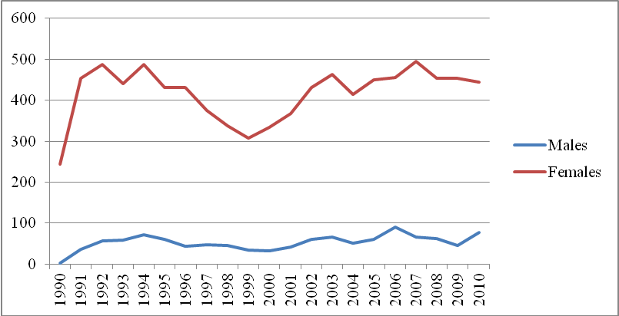

Figure 18: Percentage of Victims Served by Age Group
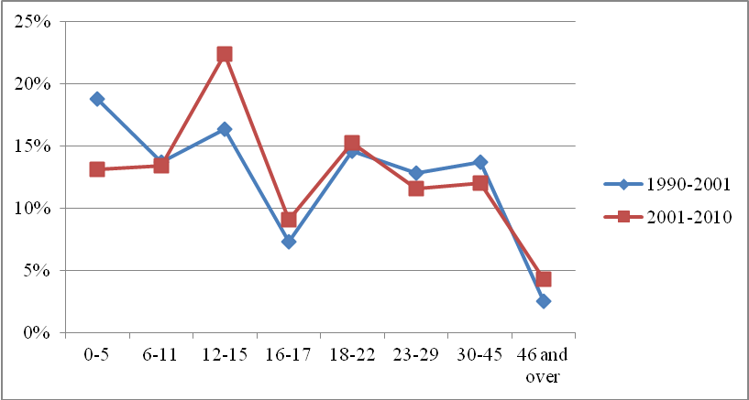

The SATC continues to service a large population of victims who are Hawaiian or part-Hawaiian. This group accounted for 28% of SATC’s population while comprising, along with other Pacific Islanders, roughly 10% of people residing in the City and County of Honolulu . Without true prevalence statistics, it is difficult to ascertain whether Hawaiians and part-Hawaiians are truly more vulnerable to sexual violence than other ethnic groups. Duponte, Martin, Mokuau and Paglinawan review data showing that Native Hawaiians have disproportionate health problems in cancer, heart disease, and diabetes and experience high rates of alcohol and other substance abuse, incarceration, and adolescent suicide. Health and social problems are exacerbated by unemployment, poverty, and lower levels of educational achievement. These socio-economic challenges should be evaluated within the historical context of cultural trauma, but they pose a compelling argument as to why Native Hawaiians, as well as other Pacific Islanders and recent immigrants may be at increased risk for interpersonal violence and trauma. It is also likely that socioeconomic status creates a cluster of vulnerabilities, including community safety factors. While we believe these data indicate higher rates of sexual assault in the Hawaiian community than amongst some other ethnic groups, we are also hopeful that culturally specific programming for Native Hawaiians at SATC may account for a portion of this disparity. It would be encouraging if culturally appropriate outreach has resulted in increased knowledge of SATC in Hawaiian communities, as well as a reputation for sensitive service delivery.

Table 17: Percentages of Clients by Ethnicity, 1990-2001 compared to 2001-2010

Ethnicity | 1990-2001 | 2001-2010
Hawaiian/part Hawaiian  Caucasian  Filipino  Japanese  Black  Samoan  Korean  Hispanic  Chinese  American Indian/Native Alaskan  Other Pacific Islander  Vietnamese  Other Asian (not mixed)  Other (Not mixed)  Mixed (non-Hawaiian) | 28.8  26.3  7.5  6.2  2.8  2.1  1.8  1.8  1.5  1.0  0.7  0.3  0.7  0.9  17.4 | 28.2  22.7  8.1  5.6  2.2  2.1  1.3  2.8  1.4  0.3  1.4  0.2  0.7  0.6  22.4

Alcohol Use

Victim use of alcohol or drugs at time of the assault was recorded more routinely in this study than in the prior ten year study; over sixty percent of the cases recorded whether or not the victim had been using drugs or alcohol. Because impaired judgment or capacity of victims does not create abuse, and care must be taken in interpreting these data, the assailant use of drugs and alcohol, is arguably of more interest as such use has a direct effect of reducing inhibitions and has been used to justify sexually assaultive behaviors.

The key finding we emphasized regarding alcohol impairment in this study involves the fact that over half of sexual offenders were under the influence of alcohol at the time of their crime. This shifts our focus from examining victim behavior to recognizing risk factors for potential offenders. With alcohol use, potential assailants reduce their ordinary inhibitions and may misinterpret signals from others or ignore their own value system. Further, friends or acquaintances of those who lean towards abusive or violent tendencies need to understand that alcohol may increase risk for assaultive behaviors. On a policy level, educational campaigns targeted to drinking males, for example, or to bars as a site for intervention, may need further exploration. Prevention messages are beginning to shift away from risk reduction for victims and more attention needs to be paid to initiatives directed at potential assailants and stopping offenders who commit sexual assaults.

Of course, alcohol use also is sometimes present with victims, although that in no way shifts responsibility to the victim for the assault. Data reflected an increased use of alcohol for female and male victims relative to the prior 10 years, and this is concerning because it may increase vulnerability to sexually aggressive or inappropriate behaviors, as well as impair the ability to resist. However, these numbers may be reflective of the age differences between the two periods. Compared to the previous ten years, victims under the age of 18 were less likely to use alcohol in the current analysis. However, for victims between the ages of 18 and 29, alcohol use increased over 10%. Alcohol consumption disrupts higher order cognitive processes and makes it difficult for the drinker to interpret social intent or social cues (Abbey et al., 2001). Since the majority of alcohol use in this study occurred in older teen and young adult female victims, it is important to provide ongoing education on personal safety and the effectiveness of bystander interventions to these vulnerable age groups.
Police Reporting
In contrast to the previous ten years, ethnicity was not a significant predictor of police reporting. Police reporting increased about 5% in almost all ethnic groups (with the exception of ‘Other Asian’ which decreased about 20%). In fact, one important finding is that Japanese women were no longer the least likely to report. While this trend in the past ten years may have been attributable to collectivistic cultural influence, it is clear that the instance of reporting for Japanese women and minors has been if not reversed, substantially impacted by societal or political changes targeted towards increasing police reporting. The “Other Asian” group is likely an amalgamation of survivors who are immigrants or victims where English is a second language. If so, the decrease in reporting in this group may reflect cultural preferences or prohibitions regarding the involvement of law enforcement in personal or family matters. Assimilation challenges coupled with specific cultural mores may have resulted in victims’ increased reluctance in dealing with law enforcement or other agencies outside of their cultural community.

In the prior reporting period, adults were more likely to report, while the current data revealed that minors were more likely to report. However, the overall trend was decreased reporting for all victims, both male and female. Local mandatory reporting laws have not changed over the past 10-12 years and information on offenders has been posted on Hawai‘i’s sex offender registry since 2004. Despite statutory and legal steps to ensure victim safety, the culture of victim blaming is still prevalent especially if the victim does not conform to the public’s perception of the typical assault (i.e., sex abuse of a young child or a stranger rape). There continues to be an unwarranted focus on the victim rather than the offender which further perpetuates victim-blaming attitudes.

It is not surprising, then, that victims choose not to report, especially since Lisak and Miller (2005) found that “only a small minority of reported cases, especially nonstranger assaults, ever result in the successful prosecution of the offender” (p. 17). Due to low reporting rates, the majority of sex offenders are not arrested, much less prosecuted. Statistics from the Rape, Abuse, and Incest National Network (RAINN) show that out of every 100 rapes, 46 get reported to the police, 12 lead to an arrest, 9 get prosecuted, 5 lead to a felony conviction and only 3 assailants will spend time in prison (www.rainn.org/get-information/statistics/reporting-rates). These facts may also impair follow-through with criminal prosecution, since the public is aware that conviction rates in sexual assault cases are so abysmal compared with certain other crimes. However, reporting to law enforcement is one important option in keeping offenders accountable. Paradoxically, the increasing severity of sex offender laws may sometimes be a deterrent to reporting, especially in child abuse cases where the assailant is a family member. Despite the discomfort that professionals and the public experience in discussing sexual violence, attempts to increase victim reporting to the police is linked to the necessity for an ongoing, open dialogue of sexual violence in our community. Additionally, training and collaboration with the justice system (i.e., law enforcement and prosecution) is important to minimize the victim’s perceived or real barriers to police reporting. Finally, as pointed out in our last report, educational programs are essential to dispel the many myths that the general public still believes about sexual assault victims and their assailants. In the prevention arena, recent emphasis on promoting bystander interventions has been especially promising, as is addressing social norms that may tacitly endorse violence or male dominant gender-roles.

Assault Types
During this time period, fewer victims reported that they were assaulted by a stranger as compared to the previous 10 years. It is not clear whether this means that stranger assaults have truly decreased or whether SATC is seeing less of these victims because victims of stranger assaults are referred out or seeking services elsewhere. Despite the decrease in stranger assaults in the SATC population, the critical issue to remember is that contrary to the public’s perception that most sexual assaults are committed by strangers, the vast majority of victims are assaulted by people they know.

Conclusion
This study contributes to our understanding of sexual violence on Oahu in multiple ways. Despite years of effort, and setbacks due to funding restrictions, sexual violence remains a stable, but unwanted presence in our community. Consistent with the rest of the U.S., this problem is complex and continues to warrant strong and coordinated responses in order to prevent sexual assault and to intervene beneficially when it occurs. In particular, prevention of child victimization should be prioritized since minors comprised the majority of victims seen at SATC over the past 20 years. The steady rates of sexual assault need further interpretation and exploration. Are more victims coming forth due to increased awareness of SATC services? Is there actually no reduction in sexual assault despite our work? Or is more awareness and willingness to seek services a sign that we are serving more who are in need? Would greater resource allocation result in a long-term decrease in those needing services? Or would increased capacity result in widening the safety net so that more survivors would be identified and come forward? What is needed to make our communities safer from sexual violence?

Despite the cumulative data compiled by SATC, there is still no true prevalence data about the extent of sexual violence in Hawai‘i. What is known, however is that sexual violence cuts across lines of gender, age and color and affects everyone, not just the victim. Families and communities are negatively impacted by sexual assault. Rape myths and victim blaming persist making it more challenging for victims to report and for assailants to be held accountable. The general public as well as professionals often find it difficult to have a meaningful, open conversation about sexual violence due to discomfort with the topic itself. However, sexual assault is not just the victim’s problem or, for that matter, the offender’s problem. It is a public health and public safety challenge that our community has yet to fully address.

In 2010, the Office of Violence Against Women, the White House Council on Women and Girls, and the White House Advisor on Violence Against Women convened a national roundtable discussion on sexual violence in the United States (Sexual Violence in the United States, 2010). Participants outlined a number of critical steps that could advance the agenda of sexual violence prevention including, but not limited to criminal justice reform, community engagement, education and training and public awareness campaigns and social messaging. Over the past 35 years, SATC has been locally involved in all of these initiatives, and more, enabling the Center to meet its mission to eliminate all forms of sexual violence thereby furthering the safety and well being of our community. Refer to Appendix A for a brief listing of SATC’s most current initiatives.

REFERENCES

APPENDIX A: SEX ABUSE TREATMENT CENTER (SATC) ACTIVITIES
The SATC has actively worked in various sectors to address the challenge of sexual violence in Hawai‘i. Recent examples of SATC activities include:
- Collaborated with key figures in the Micronesian community on Oahu to develop their capacity to more readily identify and assist sexual assault victims in their neighborhoods.
- Updated the SATC website which now includes a prevention toolkit for child sex abuse, a video featuring adult survivors speaking out and print materials on how to speak with children about personal safety.
- Trained teachers on the SATC kindergarten through 12th grade curriculum developed in collaboration with the State Department of Education.
- Collaborated with the Honolulu Theater for Youth to create gender specific high school plays to promote respectful relationships.
- Trained Honolulu police recruits as well as language interpreters on victim sensitivity during interviews.
- Worked with athletic coaches to reach out to high school athletes in taking a stance against sexual violence in all forms.
- Produced radio spots to encourage victims to call the SATC 24-hour hotline and developed public awareness and media campaigns such as Respect.
- Collaborated with co-members of the Hawai‘i Coalition Against Human Trafficking Task Force on an updated protocol for responding to victims of human trafficking.
- Created a medical clinic to provide specialized care to high risk victims, including victims of human trafficking and people who have been commercially sexually exploited.
- Trained healthcare providers in the identification and intervention of human trafficking patients.
- Worked to inform legislators on the reasons behind delayed reporting, thereby underscoring the need for extending the statute of limitations for civil suits.
- Worked with the Hawai‘i Sexual Assault Coalition (HCASA) to identify practice standards for sexual assault services.
- Collaborated with the Family Justice Center to develop services for victims of sexual and domestic violence.
- Through a partnership with the Judiciary, SATC provides crisis services in the juvenile detention facility and a youth shelter.
- In conjunction with the Hawai‘i Sexual Assault Response and Training (HSART) Program, SATC provides ongoing leadership in the implementation of established statewide forensic examiner training standards and statewide forensic examination criteria.

Through such initiatives, as well as the provision of direct 24/7 crisis services, medical care and therapy, SATC is better able to meet its mission to support the emotional healing process of those sexually assaulted in Hawai‘i, to increase community awareness about their needs and to reduce the incidence of all forms of sexual violence.

APPENDIX B: FREQUENCY OF VARIABLES USED IN REPORT

Variable | Number | Percentage¹
Age (in years)  0-5  6-11  12-15  16-17  18-22  23-29  30-45  46 and over  Missing | 627  641  1065  432  674  551  571  206  67 | 13.0  13.3  22.3  9.1  14.1  11.6  12.0  4.3  1.4
Ethnicity  Hawaiian/part Hawaiian  Caucasian  Filipino  Japanese  Black  Samoan  Korean  Hispanic  Chinese  American Indian/Native Alaskan  Other Pacific Islander  Vietnamese  Other Asian (not mixed)  Other (Not mixed)  Mixed (non-Hawaiian)  Missing | 1222  986  352  241  94  90  58  120  59  13  62  10  32  28  974  493 | 25.3  20.4  7.3  5.0  1.9  1.9  1.2  2.5  1.2  .3  1.3  .2  20.1  .7  .6  10.2
Marital Status (victims 18 and older)  Missing | 1800  203 | 89.9  10.1
Employment Status (victims 18 and older)  Missing | 1408  595 | 70.3  29.7
Location of Assault  Victims Home, Hotel or Workplace  Other Private Place  Outdoors  Assailants Home, Hotel or Workplace  Other Public Place  Missing | 1390  383  53  984  300  1724 | 28.8  7.9  1.1  20.4  6.2  35.7
Relationship of Victim to Assailant  Family  Authority Figure  Acquaintance  Stranger  Intimate  Missing | 960  231  946  716  334  1647 | 19.9  4.8  19.6  14.8  6.9  34.1
Number of Assailants  One  Two or more  Missing | 3162  401  1271 | 65.4  8.3  26.3
Assailant Used Threat  Missing/Unknown/Not applicable | 766  2768 | 15.8  57.3
Assailant Used Physical Force  Missing/Unknown/Not applicable | 1404  2701 | 29.0  55.9
Assailant Used a Weapon  Missing/Unknown/Not applicable | 216  2529 | 4.5  52.3
Assailant Used Deception  Missing/Unknown/Not applicable | 131  3989 | 2.7  82.5
Assailant Intimidated the Victim  Missing/Unknown/Not applicable | 724  3603 | 15.0  74.5
Assailant Injured Victim  Missing/Unknown/Not applicable | 368  3310 | 7.6  68.5
Referral to SATC  Police  Family  Friends  Self  Physician, Hospital, or Ambulance  Social Service Agency  Other  Work/School  Missing | 1251  223  173  78  786  601  289  203  1230 | 34.7  6.2  4.8  2.2  21.8  16.7  8.0  5.6  25.4
All Data on Victim Reported to Law Enforcement  Missing | 4230  604 | 87.5  12.5
¹Number reflects total percentage of all cases including missing variables.

APPENDIX C: COLLAPSING OF VARIABLES

Definitions of variable code/categories

Relationships
Intimate: Boyfriend, ex boyfriend, ex-same-sex partner, ex-fiancé, ex-husband, ex-wife, fiancé, current husband, live-in partner
Other relative: auntie, brother-in-law, brothers/step brothers, cousins, family not otherwise specified, father/stepfather, father-in-law, foster home, grandfather, grandmother, grandparents, in-laws, mother, other relative, siblings, son/stepson, uncle
Friend/Acquaintance: babysitter, boarder, boss/employer, casual acquaintance, co-worker, clergy, date, dorm mate, foster home parent, foster home other, friend, friend of the family, friend’s relative, landlord, mother’s boyfriend, neighbor, new acquaintance, nurse/school nurse, other helping professional, other institution, physician, police, prostitute customer, roommate/housemate, schoolmate, shipmate, therapist, former roommate/housemate, father’s girlfriend, teacher/professor
Stranger: Stranger
Missing: No one/None/No other unknown/Not applicable

Location of Assault
Victims home, hotel or workplace: Victim’s home or apartment, hotel, victim’s office/worksite, victim’s vehicle
Assailant’s home, hotel or workplace: Rapist’s home or apartment, rapist’s hotel, rapist’s office/worksite, rapist’s vehicle
Other private place: Building (unoccupied), cruise ship, other private place, boat, private party, other hotel, other home or apartment, other office/worksite, other vehicle
Outdoors: Beach/park, harbor/dock, woods/field/trail
Other public places: Disco/bar/club, other public locale, parking structure, public bus/transport, restaurant/fast food, school/schoolyard, store/center, street/lot/lawn, bus stop, theater, military grounds, worksite
Missing: Unknown/Not applicable

Referral to SATC
Police: Police
Family: Family specified
Self: Self
Physician, hospital or ambulance: Physician, hospital or ambulance
Social Service agency: Hotline, Mental Health, Social Services agency
Other: Other, media
Work/School: University of Hawai‘i Department of Personnel, community college department, military organization/service, school

Recommended Citation:

Nelson, D., Yanagida, E. & Plummer, C. (2012). Sexual assault victims in Honolulu: A statistical profile. Report by the Sex Abuse Treatment Center in partnership with the State of Hawai‘i Department of the Attorney General Crime Prevention & Justice
Assistance Division.

Hard copies of this report can be obtained by contacting:
Sex Abuse Treatment Center
55 Merchant Street, 22nd Floor
Honolulu, HI 96813
(808) 535-7600

The report can also be found on the SATC website www.satchawaii.org.

These numbers also do not reflect women who received services in three of Oahu’s domestic violence shelters

